|  |  |  |  |  |
| --- | --- | --- | --- | --- |
| Name of malware | Basic Static | Basic Dynamic | Advanced Static | Advanced Dynamic |
| Ryuk Ransomware | ✔ (mabel) | ✔ (edward) | ✔ (edward) | Failed(mabel) |
| Dm.exe | ✔(edward) | Failed(mabel) | ✔(mabel) |  |
| Keylogger |  | ✔(mabel) |  |  |

# 1. Lab Setup

As analyzing malware can be very dangerous and there is a chance it might result in potential unwanted results, we have decided to make use of virtual machines to help us with our malware analysis. A virtual machine is considered a safe space for us to perform our analysis as whatever happens in the VM stays in the VM and it will not affect our host machine.

## 1.1. VMware Setup

Our VM setup is VMware Workstation 16 Pro, version 16.2.2 build-19200509. We will be installing two Operating Systems to perform our analysis, Windows 8 & Windows XP.

## 1.2. Network Diagram

Both guest machines are configured as shown below. Both systems will be configured to use the host-only mode in Vmware Workstation. This is to ensure that both the VMs won't be able to access the internet. This configuration also meant that the two VMs will only be able to communicate within their own network. This is to ensure that the malware is contained in the virtual environment and will not have any chance of spreading out.

## 1.3. Network Configuration

As mentioned below, the two guest virtual machines will be configured to use the host-only mode. It will be connected to VMnet1, which is the Host-only Network. The guest machines will receive a private IP address from the VMware Workstations DHCP server. This Private IP address does not allow both the virtual machines to be able to connect to the internet.

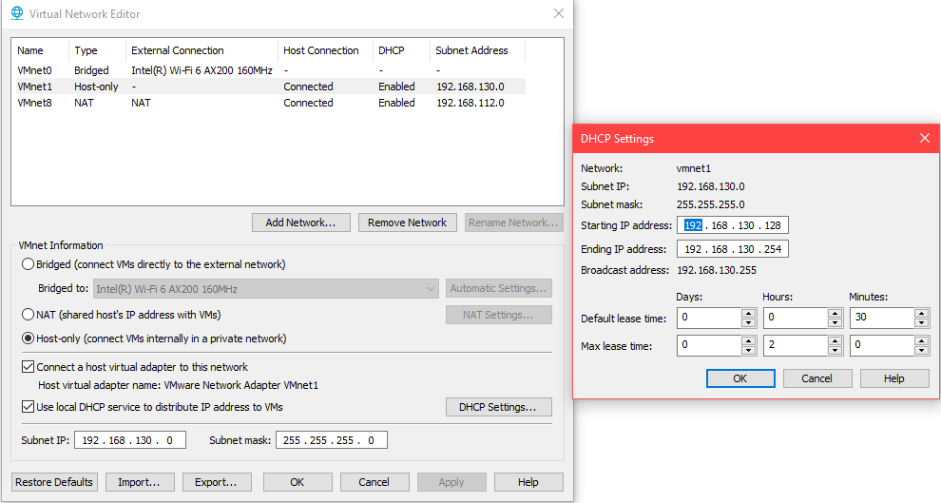

Windows 8

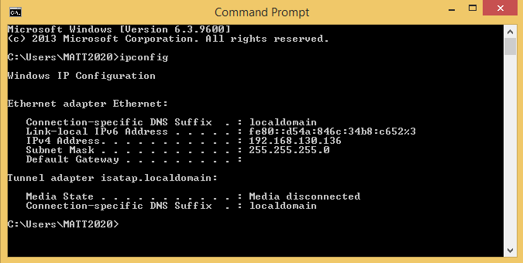

Windows XP

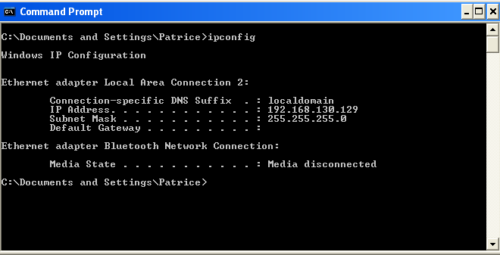

In the pictures above, both Machines have been assigned a Private IP address from VMware Workstation’s DHCP Server.

# 2. Malware Analysis Tools

## 2.1. Basic Static Tools

### 2.1.1. WinMD5

MD5 is a small and easy tool that can be used to calculate the MD5 hash of a file. This tool works easily by dragging and dropping the file that we want to check the hash value for, into the tool. This tool will also allow us to check if the malware that we are analysing is the correct one, as we can then compare the hash value of the downloaded malware file to the original hash value of the malware file.

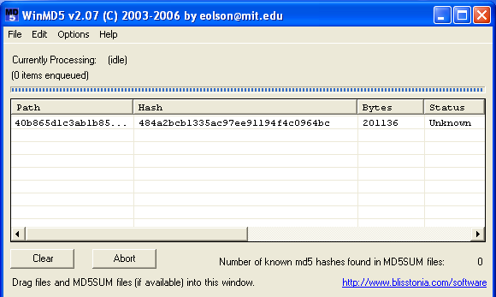

### 2.1.2. PEiD

PEiD is an intuitive application that is used to detect most common portable executable (PE) packers, cryptors and compilers found in packed or encrypted PE files. It can also be used to detect more than 470 forms of different signatures in a PE file.

In the main interface, we can view the different information about a file by dragging and dropping the file into this PEiD tool. We can see some basic information such as, the EP section, compiler used, and indications whether if the file is packed or not from the compiler section which is the “Nothing found [Overlay]*” field.

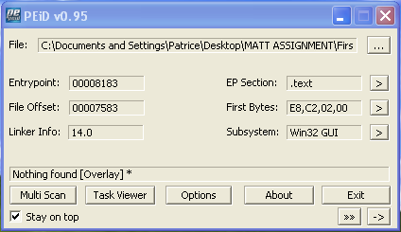

Next, under the “EP Section”, we are also able to view the virtual and raw size of the file. This will be able to help us identify whether a file is packed or not.

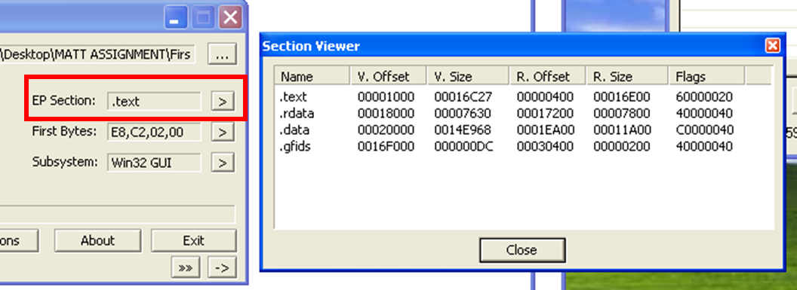

Next, under the “First Bytes” section, we have the PE disassembler and we are able to view the assembly codes of the file.

Disassemblers are used to translate machine code into human readable format and aims to recreate a compiled high-level language program from machine code to its original format.

Different disassemblers also produce different results, thus, it is good to analyse assembly codes by making use of multiple different disassemblers.

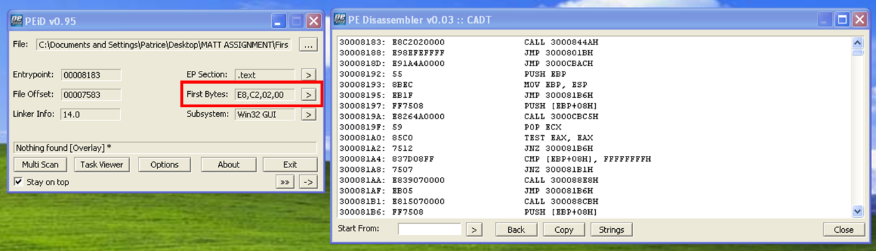

Next, we have the menu, which will be able to give us more information as well on whether the file is a packed one or not. We can click on the “Normal Scan”, “Deep Scan” and “Hardcore Scan” to help us determine if a file is packed. This is because, if the file was a packed one, by going through all the scans, the compiler section which is the “Nothing found [Overlay] *” field, could change to a common packers’ name, thus indicating that it is a packed file.

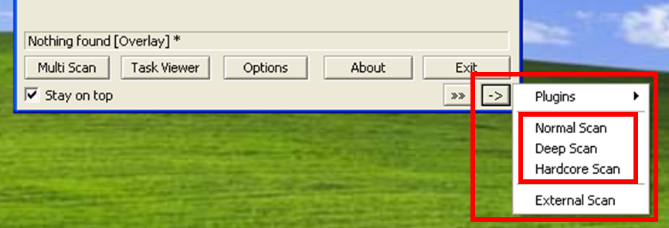

### 2.1.3. PEview

PEView refers to a viewer for portable executable (PE) files. It is a simple and compact lightweight program that views 32 or 64 bit portable executable files, showing headers and other basic information of a portable executable.

From this PEView, we are also able to get information such as, the date and time for when the file was created and more.

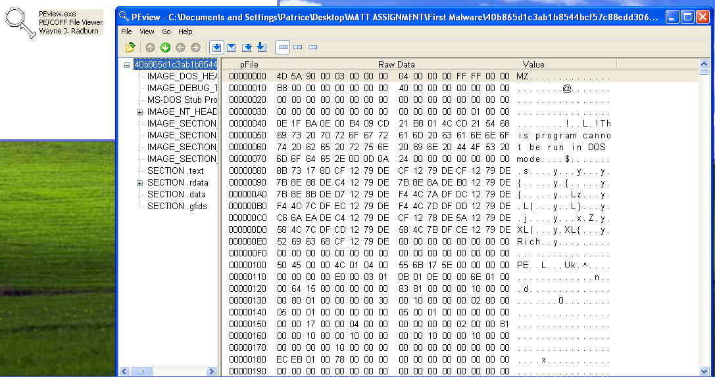

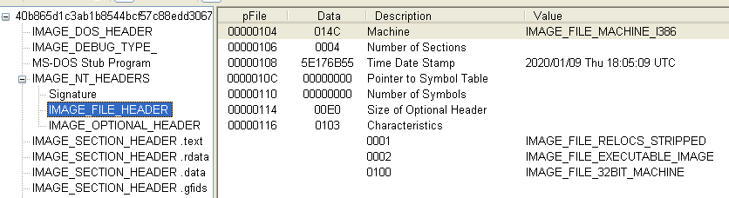

### 2.1.4. Dependency Walker

Dependency walker is a free program for Microsoft Windows that is used to list all imported and exported functions of a portable executable file. It is also able to display a recursive tree of all of the dependencies of the portable executable file. With dependency walker, we are then better able to analyse the portable executable file and better understand what the malware might be trying to do based on the different import libraries and API calls.

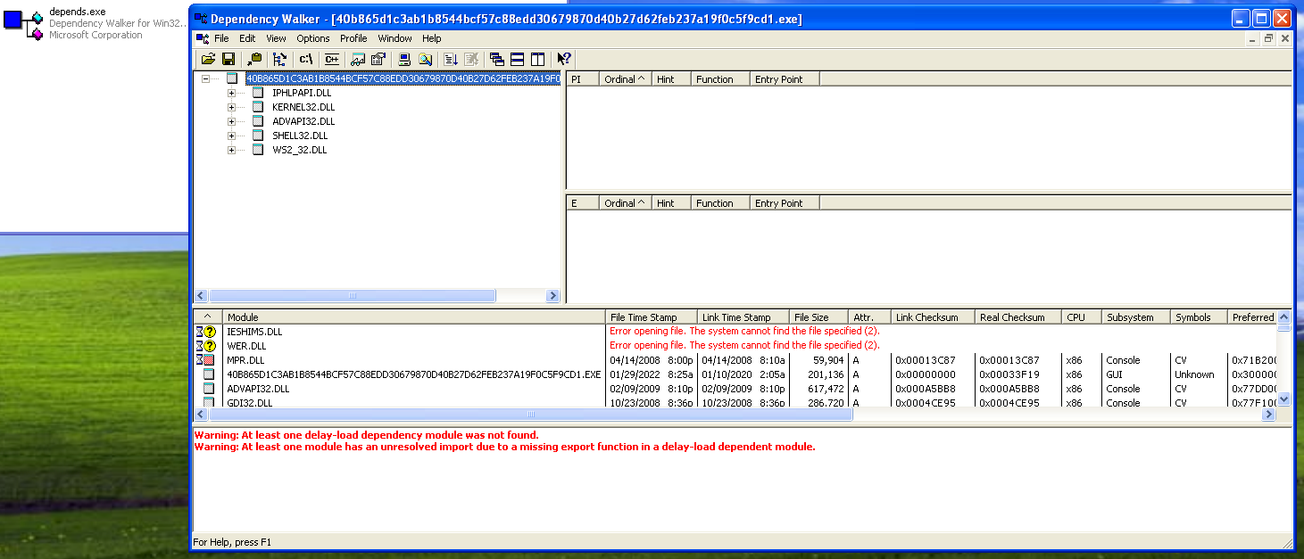

### 2.1.5. BinText

BinText is a small, fast and powerful text extractor that can find Ascii, Unicode and Resource strings in a file. It is also able to allow us to view the different strings that exist in a portable executable file including the API calls made by the portable executable file.

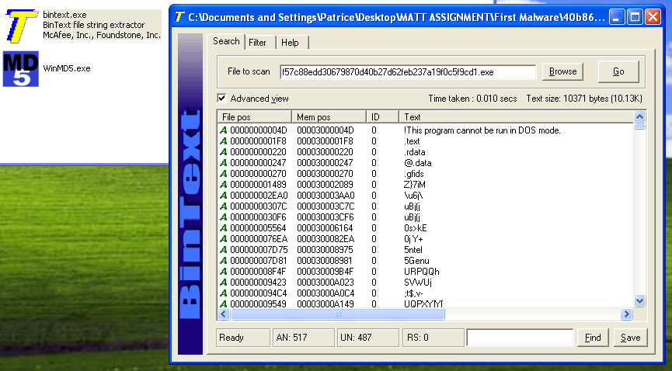

## 2.2 Basic Dynamic Tools

### 2.2.1 ApateDNS

ApateDNS is an open source Graphical-User-Interface (GUI) tool that can be used to control the DNS responses. It spoofs DNS responses to a user-specified IP address by listening on UDP port 53 on the local machine. ApateDNS allows us to view the network connections the malware makes when it is executed in the system. Although, there may be some indication of these network connections shown in basic static analysis, using ApateDNS can allow us to verify that the malware is attempting to connect to the IP addresses or hostnames that were identified. It also allows us to discover additional network connections made. Thus, ApateDNS can be used as an effective method to locate network-based indicators for the malware.

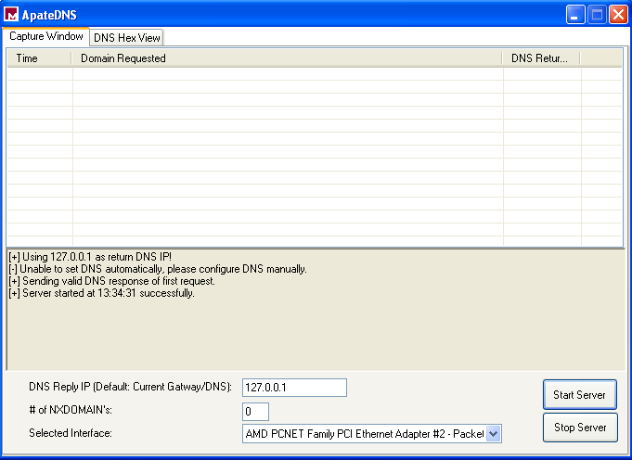

In order to properly use ApateDNS, it is needed for the system to have a manually configured DNS server address. For the DNS server address, it was set to have an ip address of 127.0.0.1, which is also known as the loopback address or localhost. This can be done by going to “Internet Protocol Properties” in the “Control Panel”. With this DNS server address set, ApateDNS can detect and capture all network connections being made by the system.

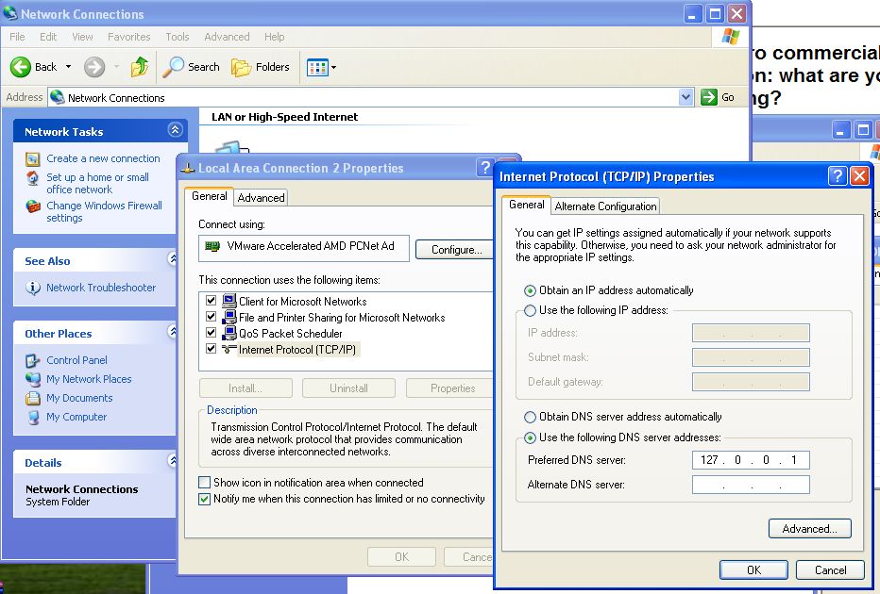

### 2.2.2 Process Explorer

Process Explorer is a tool developed by Windows SysInternals. It is used to view all running processes on the systems and displays information about the handles and DLLs for each process. Process Explorer is a useful tool in identifying the activities of the malware as we can see what processes are activated and terminated when the malware is runned. This can be a tool used to help us gain a better understanding of the malware and should be used for basic dynamic analysis.

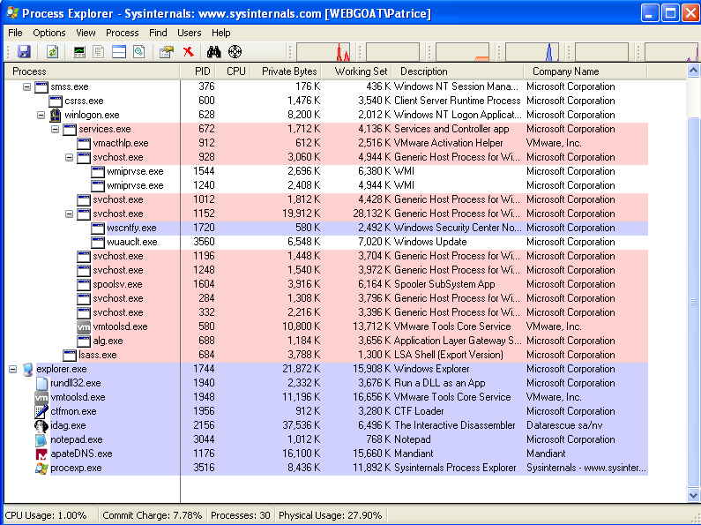

### 2.2.3 Process Monitor

Process Monitor is also a tool that is developed by Windows SysInternals. It is an advanced monitoring tool that shows live file system, registry and process activity. It combines two SysInternals utilities, Filemon and Regmon, together and provides additional features that will be useful in identifying the activities of the malware. Process monitor can be very useful, especially since it provides non-destructive filtering of data. It captures all data but users can filter the data according to information such as Process ID and Process Name. This allows the users to view only the activity of the malware which can be useful in identifying system changes made by the malware.

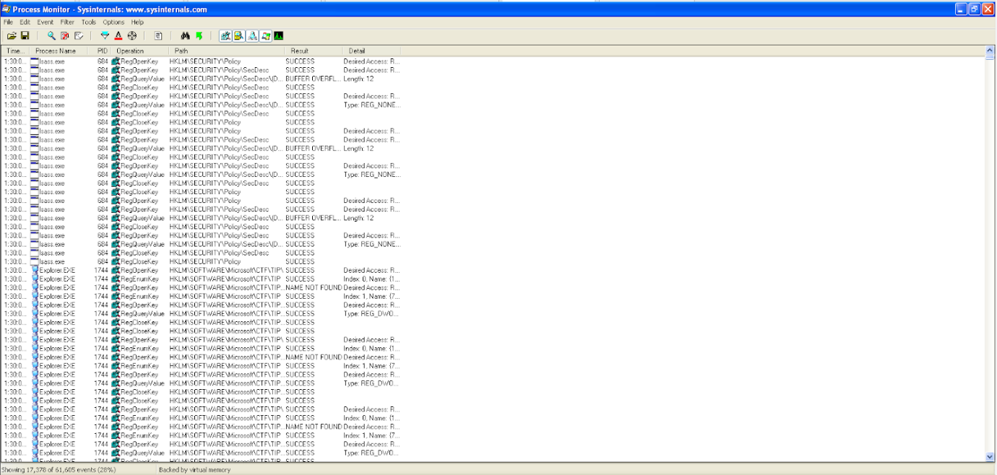

### 2.2.4 Regshot

Regshot is an open source registry compare utility that allows users to monitor for system changes. Regshot works by firstly taking a snapshot of the original registries and files on the system. Then after the malware is runned, a second snapshot can be taken. This allows for a comparison to be made for the first snapshot and second snapshot, which then allows malware analysts to identify changes made to the registries and files on the system. This tool is extremely important to use as the results made from Regshot usually allows one to gain some insight into what the malware is trying to achieve and its functionality.

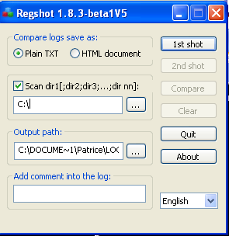

### 2.2.5 Netcat

Netcat is an utility program that supports a wide range of commands to manage networks and monitor traffic flow between systems. It is able to perform many activities such as port listening, port scanning, transferring files and can create a web server. For malware analysis, port listening can be very useful as it can help detect what TCP/UDP connections are being made by the malware. Thus, netcat will be listening on port 80 and port 443 as these are the ports which will be used by the system to make a connection to external networks. If a connection is made by the malware, the details of the connection will be shown in the command prompt.

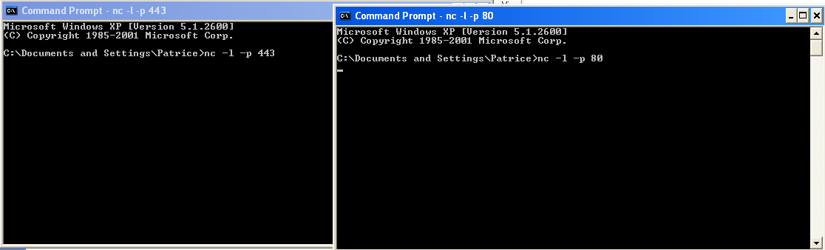

### 2.2.6 Wireshark

Wireshark is a popular open source network protocol analyser. It has many features such as troubleshooting networks, tracing connections and network analysis. Wireshark allows users to see what is happening on the network in real-time which can prove to be useful in detecting network connections made by the malware. Thus, wireshark can be used to identify network-based indicators of the malware and can also be used to track all connections the malware made.

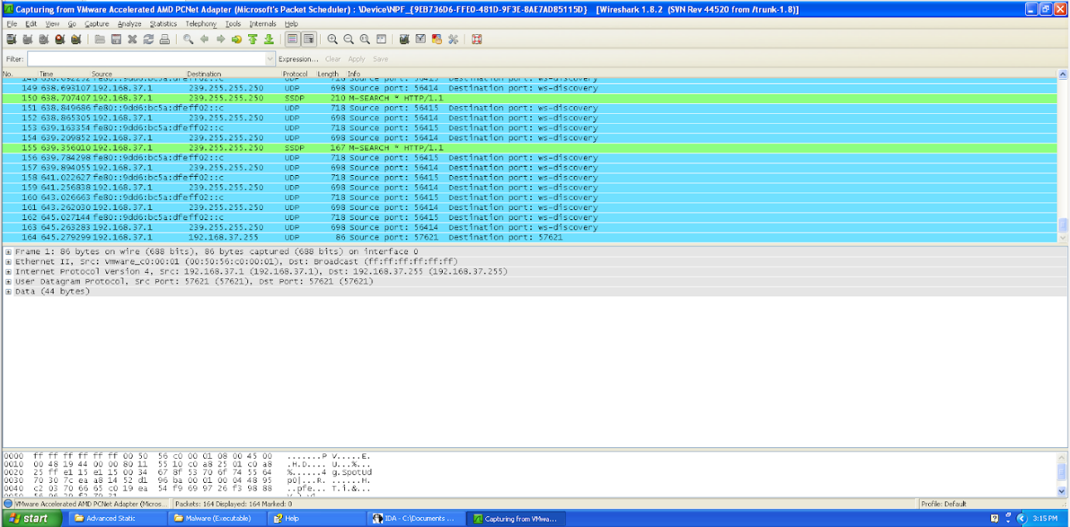

## 2.3 Advanced Static Tools

### 2.3.1 IDA Pro

Interactive Disassmbler Professional (IDA pro) is usually used to analyse nefarious programs. It is a disassembler that is capable of creating maps of their execution to show the binary instructions that are executed by the processor in assembly language. It has multiple uses such as malware and vulnerability analyses, debugging and for reverse engineering. It also supports a wide variety of file formats such as Portable Executable (PE), Common Object File Format (COFF) and Executable and Linking Format(ELF). IDA Pro also uses code signatures in Fast Library Identification and Recognition Technoloy (FLIRT) which means that it can recognise and label disassembled functions accurately. IDA Pro has many types of interface and windows that help aid the analysis of the program. It has a text interface, which shows function names, comments, and subroutine numbers.

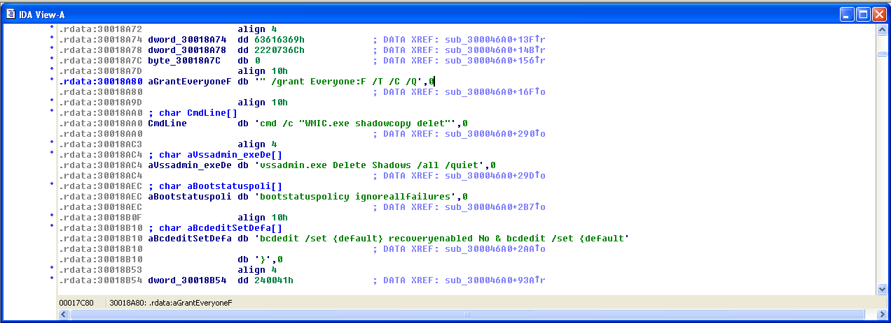

It also has a graph interface, which shows the assembly language used in each jump location. From there, malware analysts are able to see what the malware is doing as they can see the function calls the malware makes. If the malware analysts are proficient in assembly language as well, the malware analysts can have a better and clearer understanding of what the malware is trying to do.

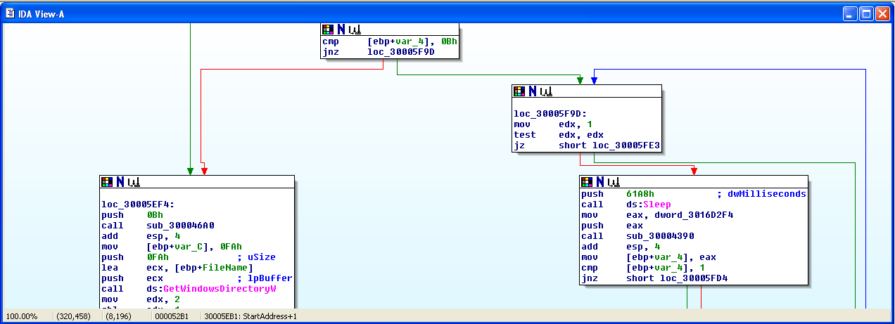

There are useful window tabs that IDA Pro provides to help with analysts. These window tabs are the “Functions Tab”, “Names Tab”, “Strings Tab”, “Imports Tab”, and “Exports Tab”. The functions tab lists all functions in .exe and the length of the function. The names tab lists every address,including functions, named code and data, and strings, with a name. The strings tab shows all strings which are longer than five. The imports tab shows the list of all imported functions and can easily allow users to locate these functions in use. The export tabs show the list of all exported functions and can allow users to locate these functions in use easily.

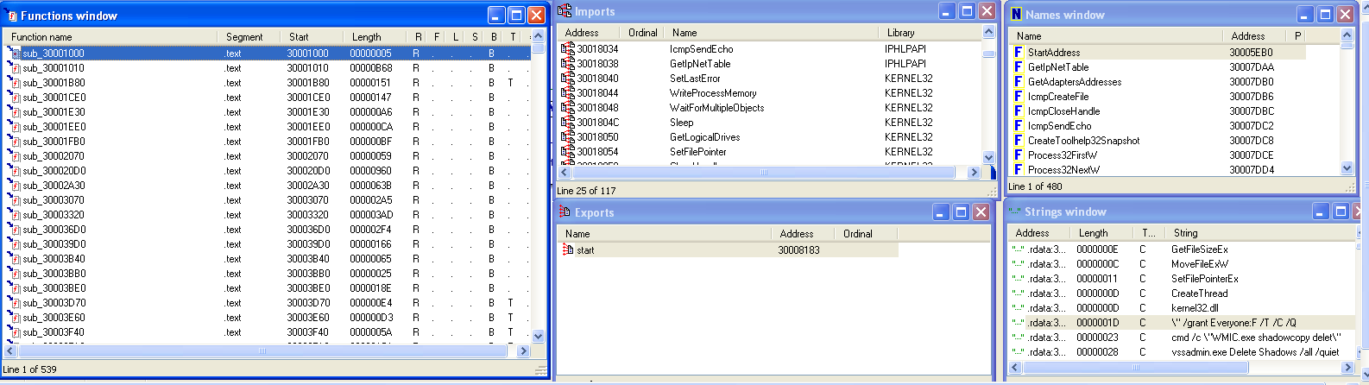

## 2.4. Advanced Dynamic Tools

### 2.4.1. OllyDbg

OllyDbg is an x86 debugger that emphasises on binary code analysis. This tool is extremely useful for when the source code is not available as it is able to trace registers, recognise procedures, API calls, switches, constants, strings, and more. It is even able to locate routines from object files and libraries. This tool can also be used to evaluate and debug malware.

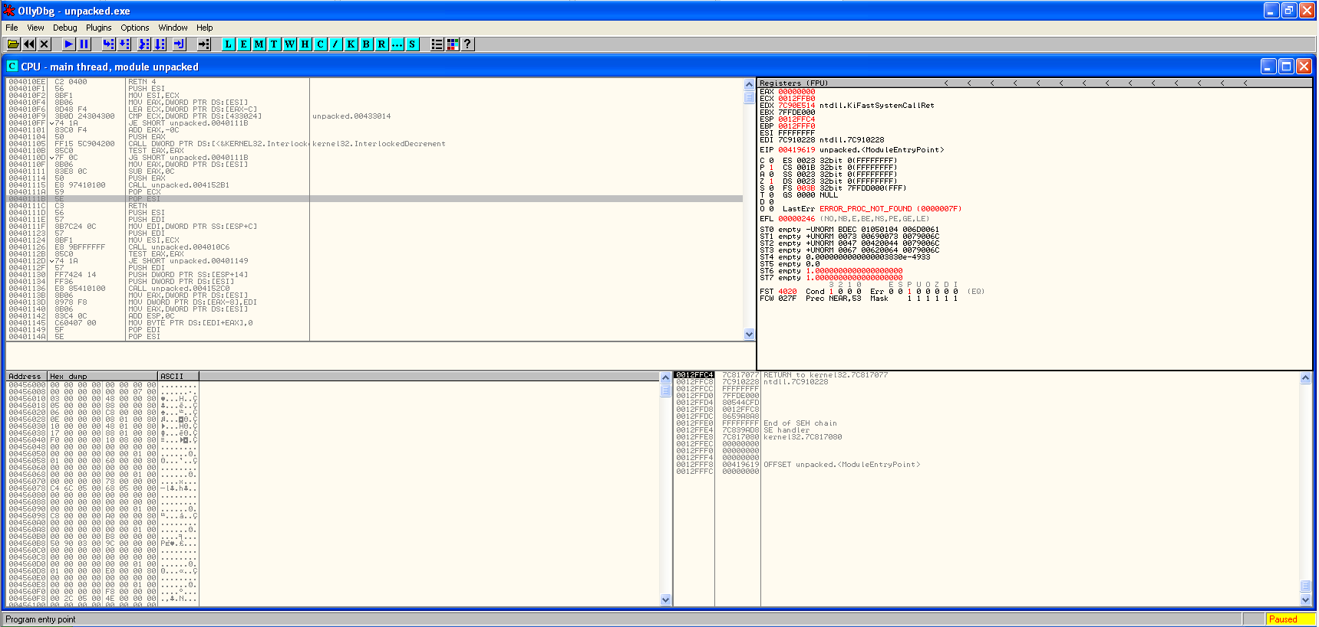

It can then be used to step out, step over and more, where we can specify how we want the malware to run. Ollydbg has the ability to debug multithread algorithms and attach to running programs. It provides malware analysers a safe space to run the malware without infecting the host system. In order to help with the debugging of the malware, breakpoints can be set to examine the values of the variables in the code so as to help make users better understand what the malware is doing. Ollydbg supports many types of breakpoints such as conditional, logging, memory and hardware breakpoints. It also traces program execution and logs arguments of known functions so as to aid in the debugging process.

# 3. Analysis of Malwares

## 3.1 First Malware

MD5 Value: 40b865d1c3ab1b8544bcf57c88edd30679870d40b27d62feb237a19f0c5f9cd1 (RyukRansomware)

### 3.1.2 Results from Basic Dynamic Analysis

**\* Multiple runs of the malware were required during this analysis and thus the name of the application the malware created can differ between images. The process IDs may also differ between images. \***

#### 3.1.2.1 Immediate Changes Made

The screenshot below shows the contents of the file, “Malware (Executable) “, before the malware was runned.

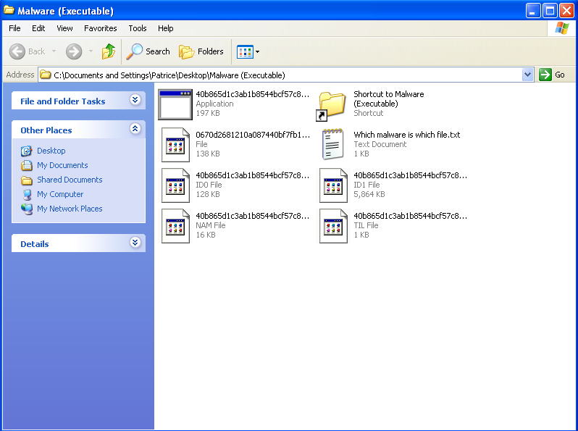

After running the malware, three changes can be observed. The most obvious changes are the additions of “AFsfhMk.exe” and “RyukReadMe.html”. The last change is that the files’ extension were modified and became a .RYK file.

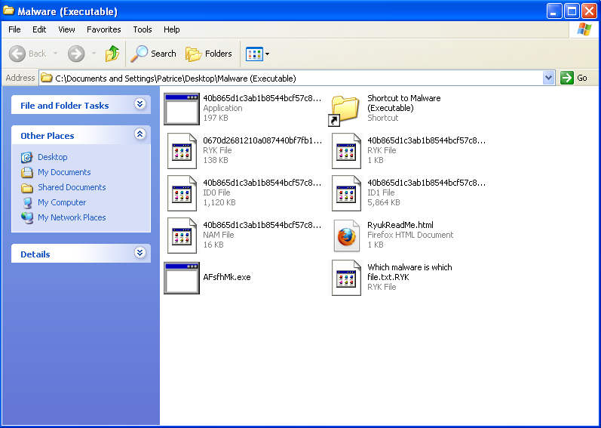

There were also several error messages that were shown. One example of an error message that the victim will receive is, “Windows - No Disk”. This specific error message could imply that the malware has deleted information resulting in the corruption of the windows disk. The other error messages can indicate that important contents in the system may have been corrupted as well, which may affect the operation of the system.

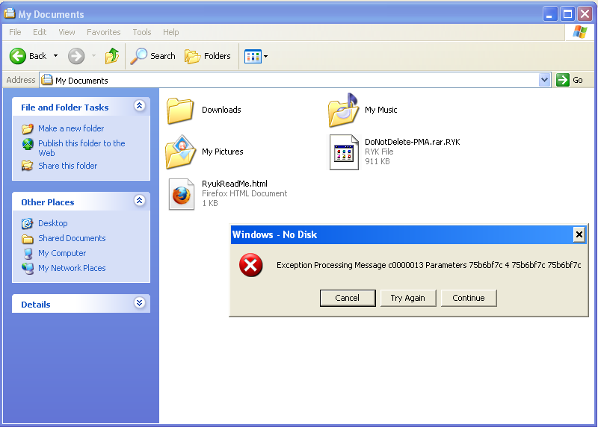

All files in the system had their file extensions modified to have a .RYK extension. All of these files could not be open and accessed. The reason why this occurs is because Windows is unable to find the program which created the files. This suggests that the files in the system have been encrypted and can no longer be accessed.

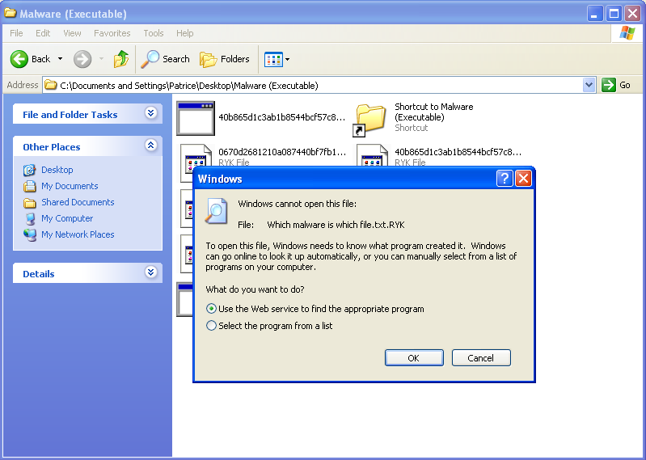

We tried to open the .html file to see what information this file contains. When viewed in firefox, we can only see only three details. In the centre of the webpage, we can see the words,”Ryuk”, at the centre of the webpage. At the top left of the web page, we can see an email address [pakuroume1977@protonmail.com](mailto:pakuroume1977@protonmail.com). At the bottom right, we can see a phrase, “balance of shadow universe”, which could have perhaps been the slogan of the group of attackers who configured this malware. As this html file can be found everywhere in the system, the attackers might be highlighting the fact for the victims of the malware to contact that email to find out more about what has happened to their system and files.

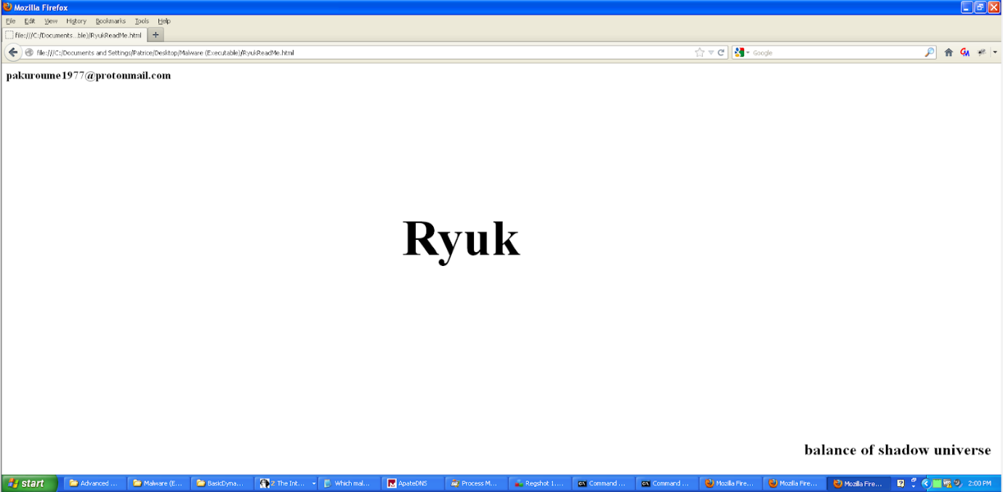

Another observation that was made was that when the executable created by the malware was runned, another executable with a different name was created in the same folder.

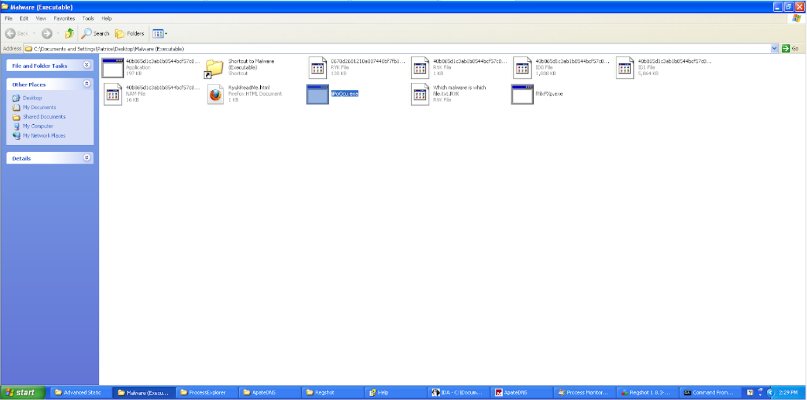

The last observation that was observed was that “Dr Watson” was created in the directory, “C:\Documents and Settings\All Users\Application Data\Microsoft”.

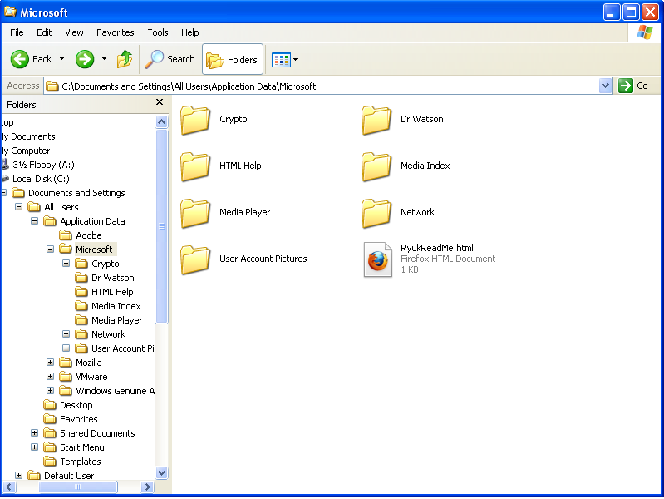

The contents of the “Dr Watson” folder showed three items. The first is “drwtsn32.log.RYK”, second is “user.dmp.RYK” and the last time is “RyukReadMe.html”.

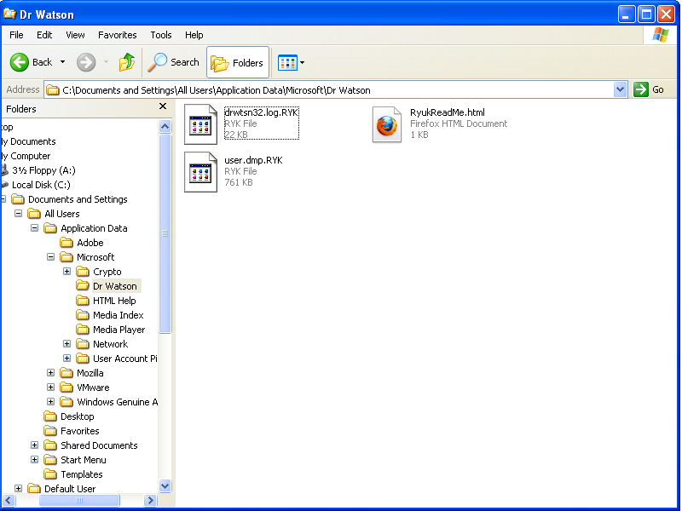

#### 3.1.2.2 Process Explorer Analysis

After letting the malware run for a few minutes, it was noticed that many command prompt instances were being created and .exe applications were being executed. Soon after, processes that were running on the system started to end and close automatically. The cmd instances created by the malare were also deleted and only, “AFsfhMk.exe” was left being shown on the process explorer. “AFsfhMk.exe” is an application that was created by the malware and can be seen from 2.1. Due to the malware ending the processes, the virtual machine has to restart several times from a saved snapshot in order to conduct proper analysis. Thus, the names of the application created by the malware as well as the process IDs may differ between images.

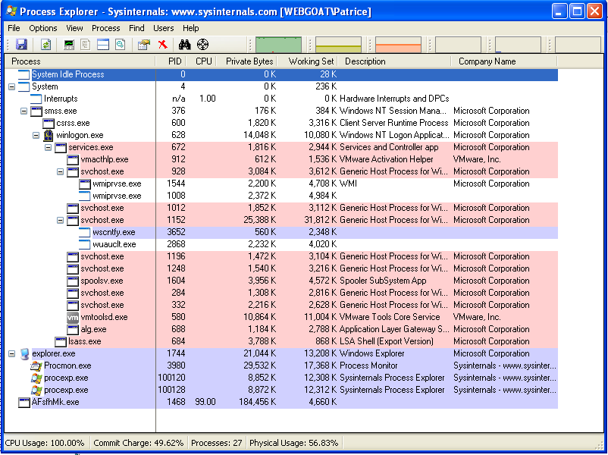

The image below shows the process explorer after the malware was runned, before it started killing processes. As we can see from the image, a total of five command prompt instances were launched. Out of these five, two of them are being used for the netcat operation. The third one is created as a child of rundll32.exe and appears to be running “wmic.exe”. The fourth command prompt is created as a child under “suZKjRl.exe” and is also running “wmic.exe”. “dwwin.exe” was also created under “suZKjRl.exe”. The last command prompt was created as a child under the malware, “40b865d1c…” and was running, “vssadmin.exe”.

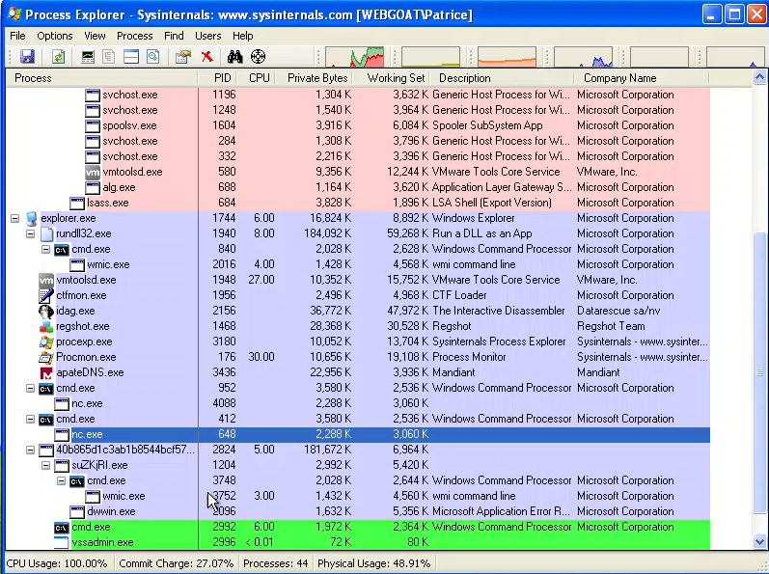

We first hovered above the “wmic.exe” that was running under “rundll32.exe”. We found out that the command prompt is running the command, “WMIC.exe shadowcopy delet”. This leads us to believe that the command prompt is actually running “WMIC.exe shadowcopy delete” which lead us to the conclusion that shadow copies are being deleted on the windows system.

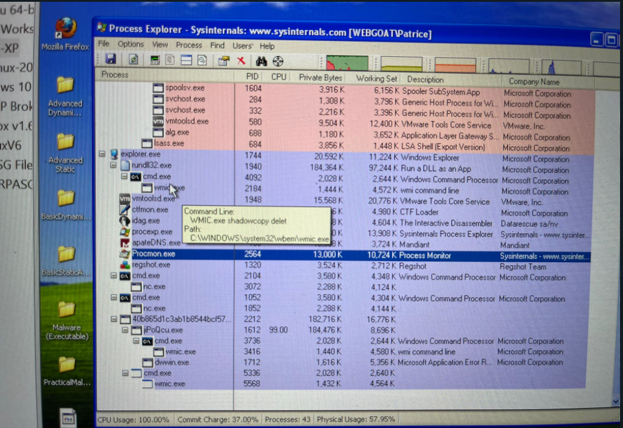

We then hovered above the “wmic.exe” that was running under the malware. It was found that it was also running the same command as the “wmic.exe” under “rundll32.exe”.

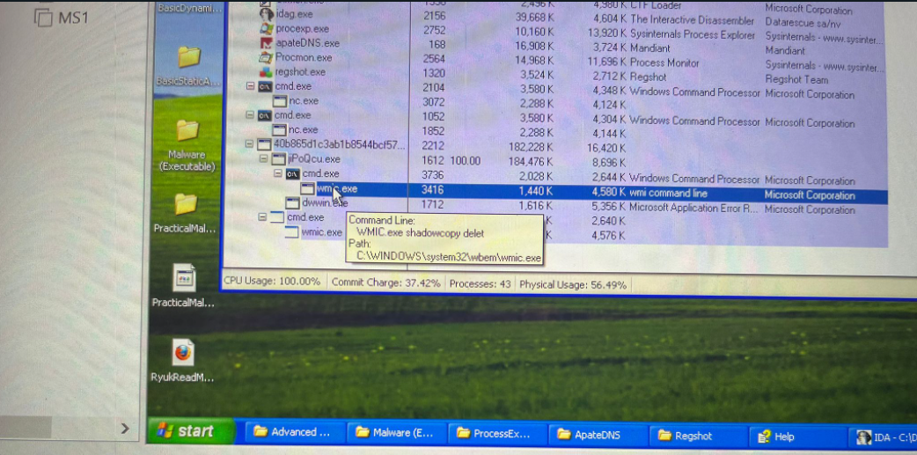

Unfortunately, for the command prompt that was running “vssadmin.exe” we were not able to hover over it to see what command it is trying to execute as this process shuts itself down very quickly after the malware is runned.

An error message relating to the application created by the malware was also displayed. This error message stated that “[Name of Application].exe” has encountered a problem and needs to close. In this case the [Name of Application] is “jiPoQcu.exe”. When this pop-up was closed, drwtsn32.exe replaced dwwin.exe. Soon after, “drwstn32.exe” stopped running automatically.

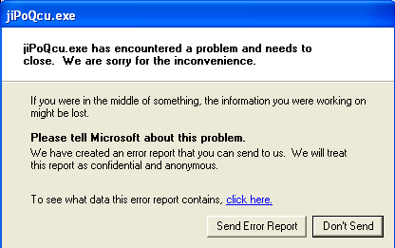

We managed to view the properties of “drwstn32.exe” before it closed but not much information could have been retrieved from it. We could only determine that the application created by the malware was the parent of “drwstn32.exe”.

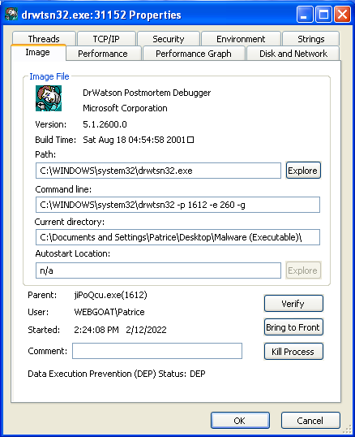

Lastly, for the process explorer analysis, we viewed the handles that were running on the system and managed to identify malware mutants that were installed on the system. A mutex is created by a malware when it is runned and is used to ensure that another instance of the malware is not runned. The mutex ensures that only one malware is running on the instance at one time so as to avoid conflict over the files stored on the system.

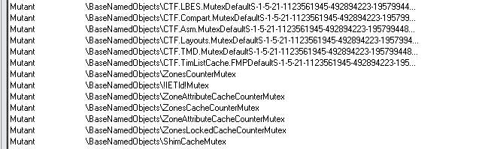

#### 3.1.2.3 Process Monitor Analysis

##### 3.1.2.3.1 wmic.exe

We first checked the registry and files changes in which “wmic.exe” has done. Since there are many items the process monitor shows, we filtered the process monitor based on the process ID of the application so that the output only shows changes made by the specific application. From there, we analysed the actions “wmic.exe” made and found a few suspicious actions. The first suspicious lines of code that were found were the usage of the registry, “HKLM\System\CurrentControlSet\Services\Tcpip\Parameters”. This registry is related to the standard TCP/IP network protocols which suggests that the malware may be connecting to the internet or may be making external connections to gain resources to infect the host system.

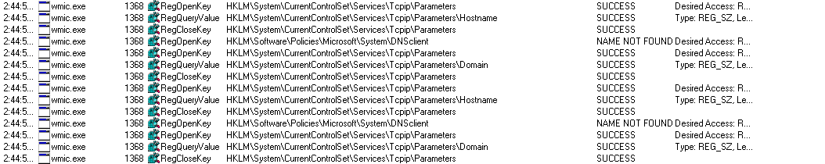

The next suspicious lines of code that were identified is that “wmic.exe” was found using the registry, “HKLM\Software\Microsoft\WBEM\CIMOM”. This registry contains the registry keys for Windows Management Instrumentation(WMI), which can give admins access to powerful system monitoring tools. With the malware using this registry, it may indicate that the malware can be involved with attacks such as enumeration and information gathering.

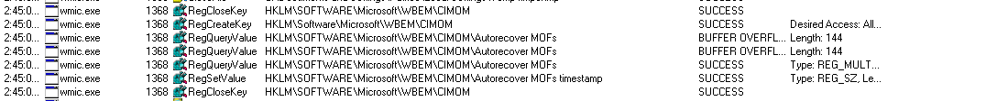

The only suspicious lines of code we could find from the malware executable was, “HKLM\SOFTWARE\Microsoft\Cryptography\Defaults\Provider\Microsoft Enhanced RSA and AES Cryptographic Provider [Prototype]\Image Path”.

##### 3.1.2.3.2 Executable Created by Malware (kNrkjDb.exe)

We then analysed the actions made by the executable that was created by the Malware. There were many suspicious lines of code that were identified which can give us an idea of what the malware is trying to achieve. The first group of suspicious lines that was identified is “C:\AUTOEXEC.BAT”. “C:\AUTOEXEC.BAT” contains DOS commands that are executed automatically when the system launches. This may imply that the malware could have launched a script that performs malicious actions such as manipulating files and altering system configurations everytime the system boots. Depending on the severity of the script, normal operations may not be possible as software components can be corrupted.

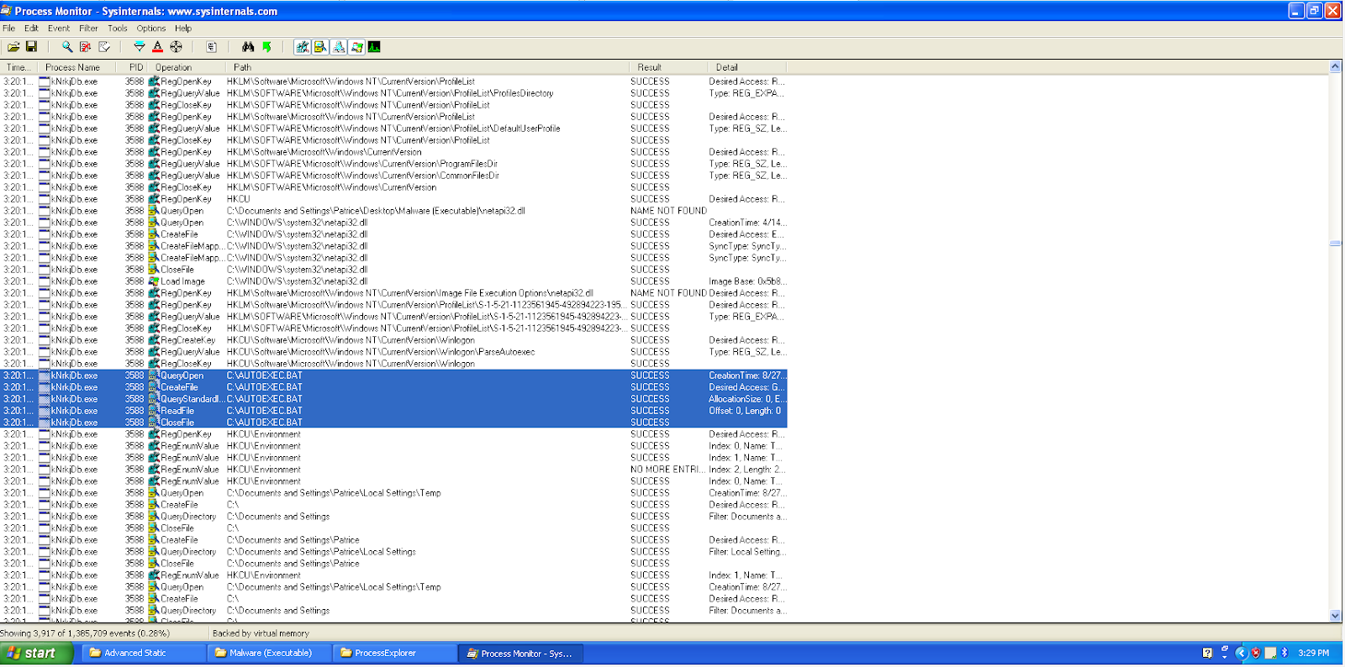

The second group of lines that were detected to be suspicious is “HKLM\SOFTWARE\Microsoft\Cryptography\Defaults\Provider\Microsoft Enhanced RSA and AES Cryptographic Provider (Prototype)\Image Path”. This could signify that the malware might have used RSA and AES algorithms to encrypt the system files which could have been the cause of why the files on the system can no longer be accessed.

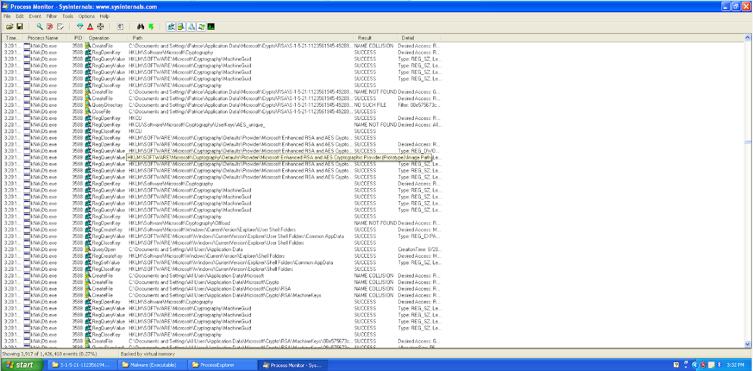

The third group of lines that were detected to be malicious is “C:\WINDOWS\system32\icacls “A:\*” \grant.exe”. The “icacls” command used in the command prompt is to modify the discretionary access control lists that have been applied on the files in the directory. This means that the malware might alter the permissions on all the files in the directory so that they can be accessed and be modified by the malware.

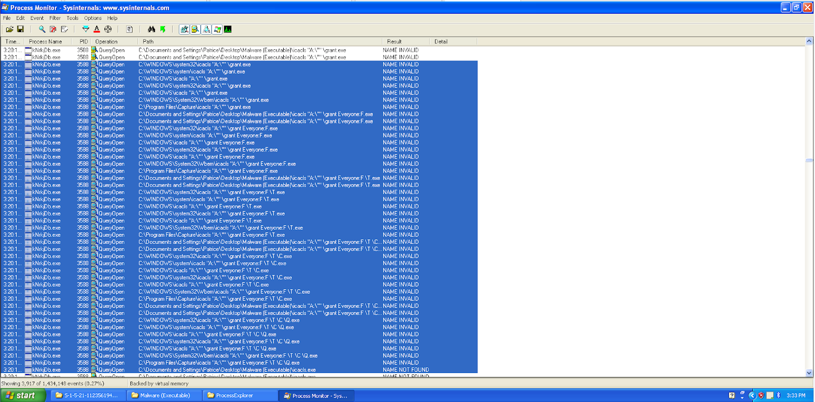

The fourth group of lines that were detected to be malicious is the usage of the command “C:\WINDOWS\system32\vssadmin.exe”. “Vssadmin.exe” is also known as “Volume Shadow Copy Service” which is a windows service that allows taking manual or automatic backup copies of computer files. This command is usually used by malwares to delete volume shadow copies stored on the computer, which means that there will be no more backup of the files installed on the system.

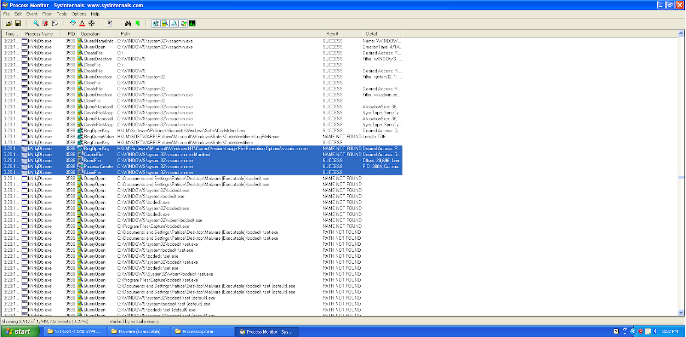

The fifth group of lines that were detected to be malicious is the usage of the command, “C:\WINDOWS\system32\bcdedit \set {default} recoveryenabled No.exe”. This command is usually used so as to disable automatic startup repair and since this is a command that is forcefully executed by the malware, it can indicate that the malware does actions that corrupt some software features and aims to prevent Windows from automatically recovering these errors.

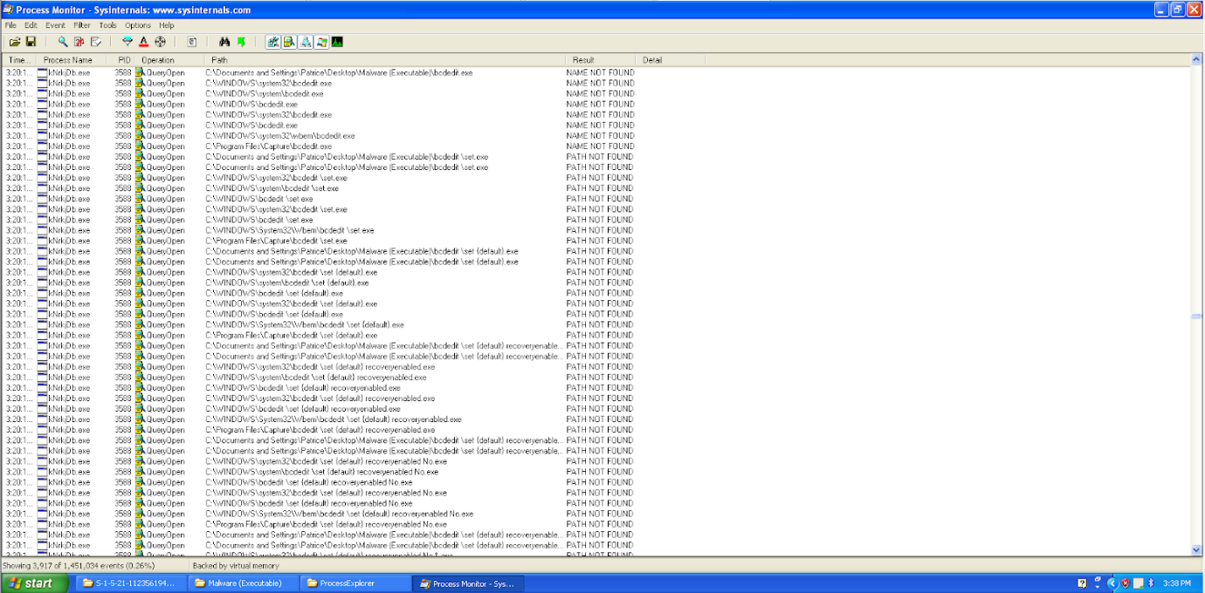

The sixth group of lines that were detected to be malicious is the usage of the command, “C:\WINDOWS\system32\bootstatuspolicy ignoreallfailure.exe”. This command means that the malware forces the computer to ignore errors relating to a failed boot, failed shutdown, or failed checkpoint and forces it to attempt to boot normally despite there being errors. This implies that the malware could be trying to hide its malicious actions that results in the computer not being able to boot properly.

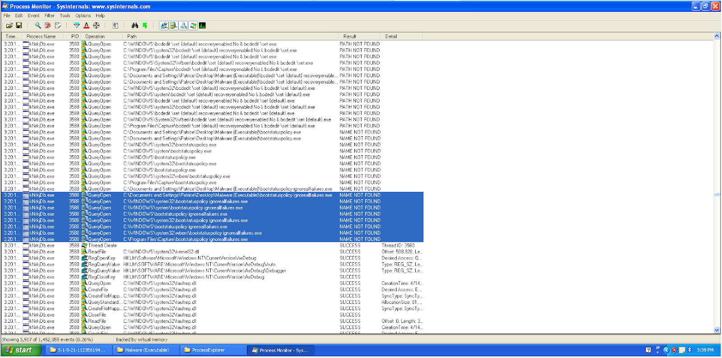

The seventh group of lines that were detected to be suspicious is the creation of the files, “dwwin.exe” and “drwtsn32.exe”. As shown by the process explorer, these two executables were created when the malware was runned and the image below confirms that the malware was the one who is responsible for the creation of these two applications. Unfortunately we were not able to find out much about what these applications can do.

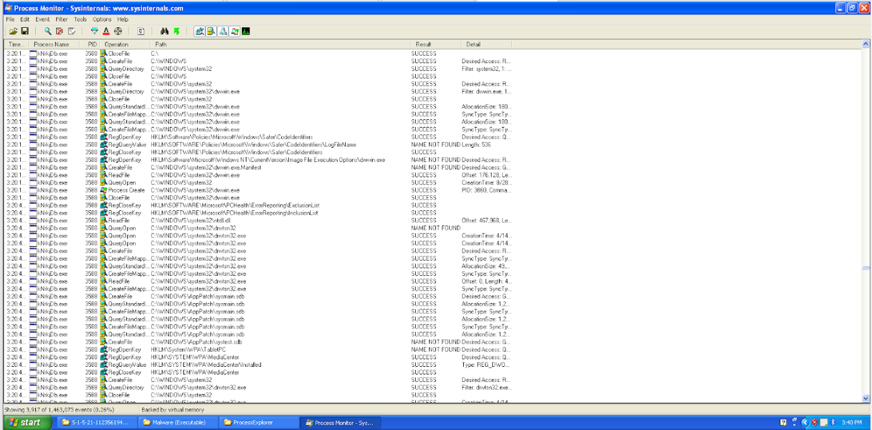

The last group of lines that were detected to be suspicious is the access of the registry, “HKLM\Software\Policies\Microsoft\Internet Explorer\Main\FeatureControl\FEATURE_HTTP_USERNAME_PASSWORD_DISABLE”. The standard for the Uniform Resource Locator (URL) allows for user authentication to be included in the URL. The malware may be trying to access this registry to edit the policy so as to enable usernames and passwords. If it is allowed, victims can be directed to dangerous websites.

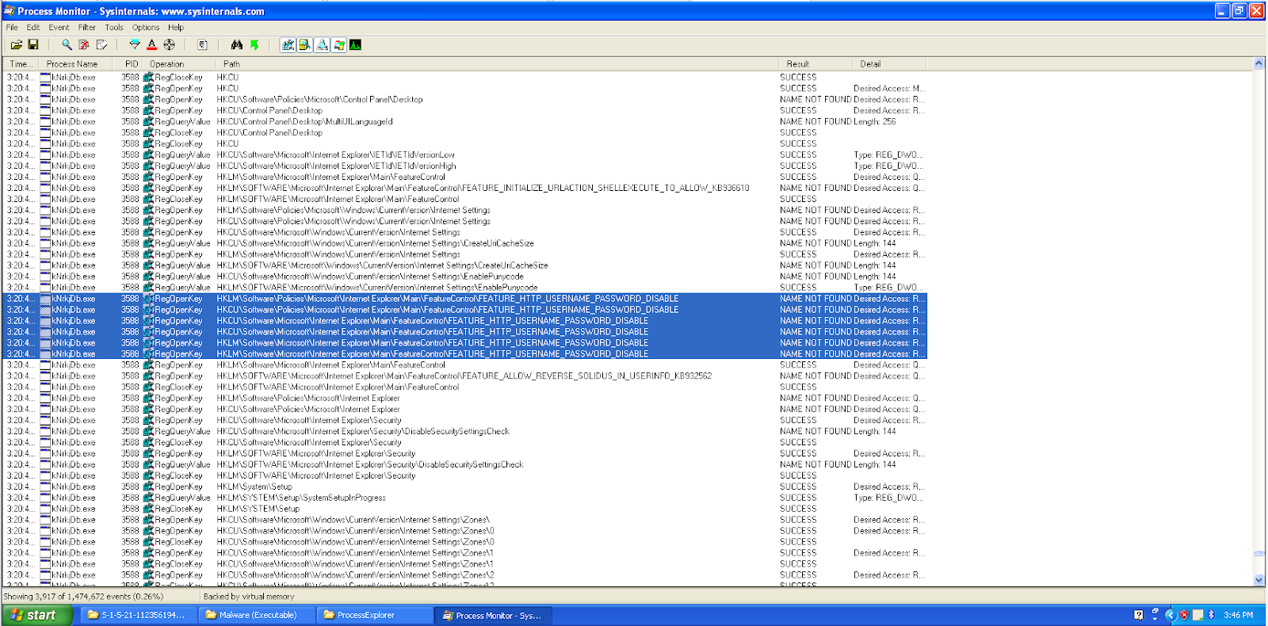

##### 3.1.2.3.3 Malware (40b865d1c3ab…)

Next, we analysed the actions of the malware that was tracked by Process Monitor. Since this is the parent process for both “wmic.exe” and the created executable, it consists of many of the same lines of code and thus we only placed groups of suspicious lines that were unique to the malware. We only managed to identify one such group of lines to be suspicious and that is the addition of the files, “RyukReadMe.html” and “C:\CONFIG.SYS.RYK”. From these lines of codes, we can see that basically every directory has a “RyukReadMe.html” file and every file in the directory has been modified to have an “.RYK” extension.

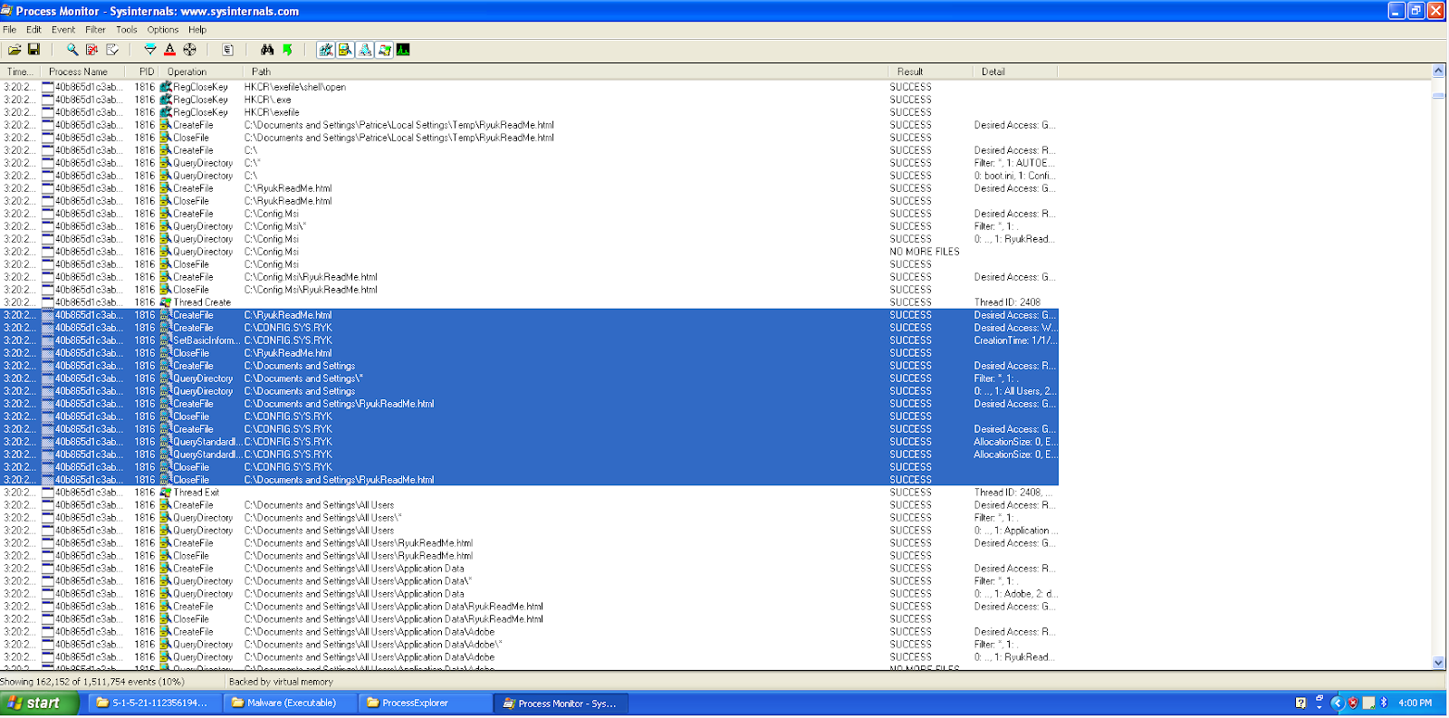

##### 3.1.2.3.4 drwtson32.exe

Lastly, we analysed the actions of “drwtson32.exe” to see if anything malicious can be found. Only two groups of line were identified to be suspicious. The first is the creation of files in the system. This application created the folder, “Dr Watson” in the directory, “C:\Documents and Settings\All Users\Application Data\Microsoft\Dr Watson”. Inside this created folder, we can see another file called, “user.dmp” was created as well.



The second group of lines is that multiple “WriteFile” commands were being made to the file, “user.dmp”. Although we were not able to find out what was being written to this file, we assumed that the malware was saving all original information and content of all system files to this file.

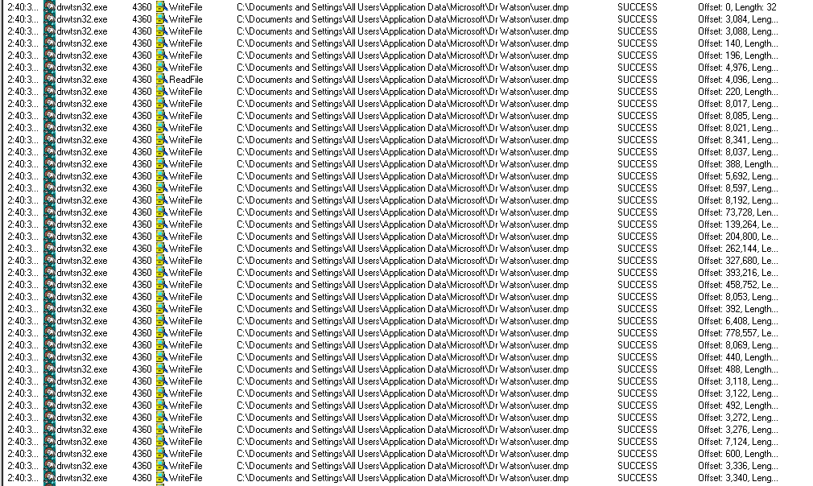

#### 3.1.2.4 Reg Shot Analysis

There were a large number of changes shown by Reg Shot. Some of the changes indicate suspicious activity with the first one involving the registry changes. There were changes made to “HKLM\SOFTWARE\Microsoft\WBEM\WMIC”. When “mofcompstatus” was searched online, not much information were identified and the results only showed other malwares which means that this registry change can be used for malicious purposes. “Cli.mof, CliEgAliases.mof, and CliEgAliases.mfl” can be used by the malware to cause startup or runtime errors which can result in the failure of executing some of the programs.

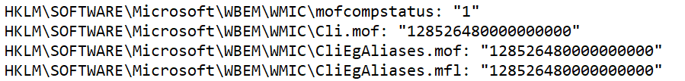

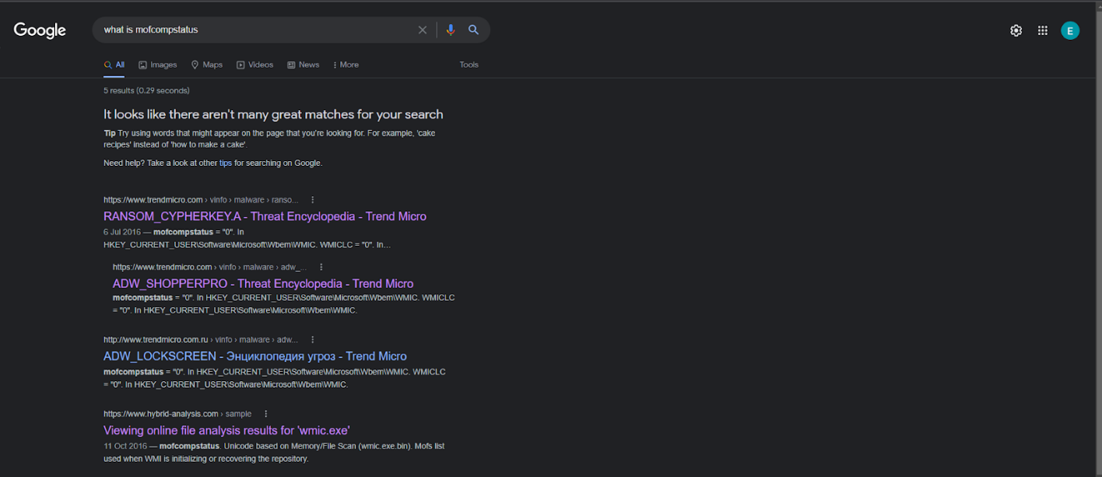

The second change involves the addition of registries. The registry, “Software\Microsoft\Windows\CurrentVersion\Run\svchost: “C:\Documents and Settings\Patrice\Desktop\Malware (Executable)\suzkjRi.exe” was added. “suzkjRi.exe” is the name of the executable created by the malware and by adding this executable to this registry,it means that this executable will be executed at every Windows launch, making the malware persistent.

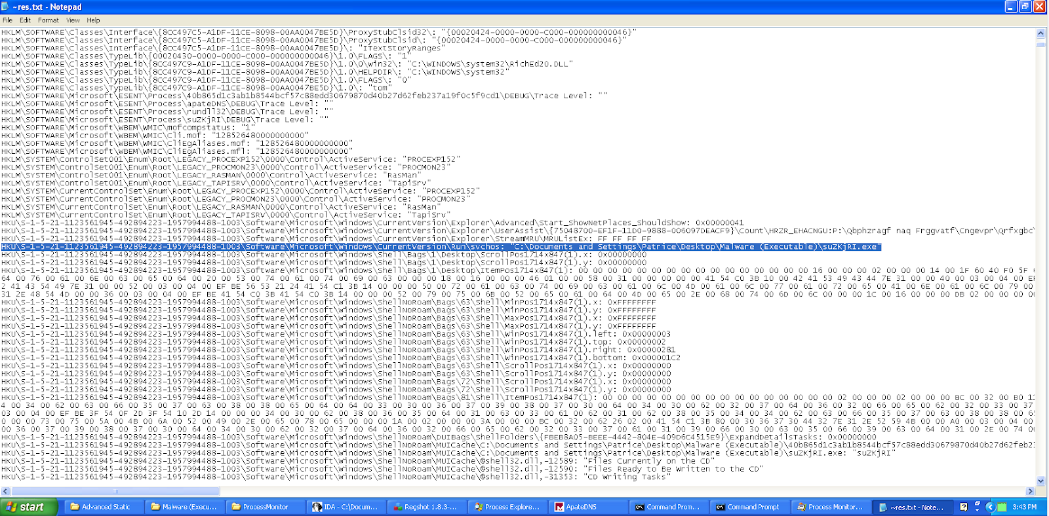

The third change worth noting is the huge number of deletion and addition of files. By comparing the next two screenshots, we can see that a large number of files were added and deleted from the system. If we analyse more closely, we can see that the files that were deleted are files that existed on the system and the files that were added were the same exact files that were deleted but it has an additional, “.RYK” in its name. This means that close to every file in the system has been encrypted and can no longer be accessed by the user.

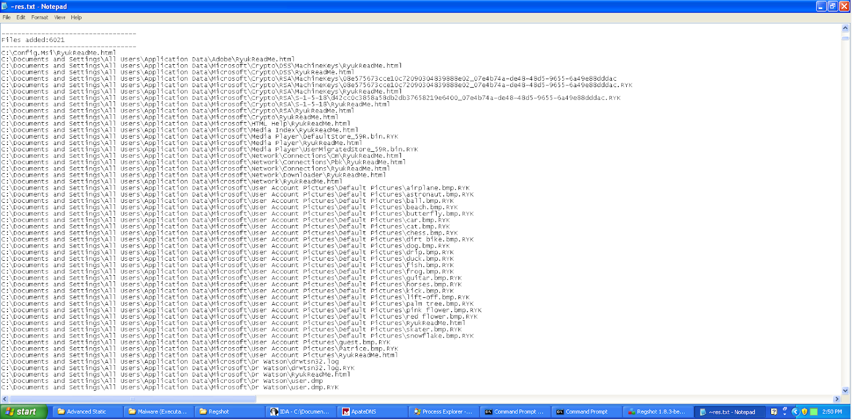

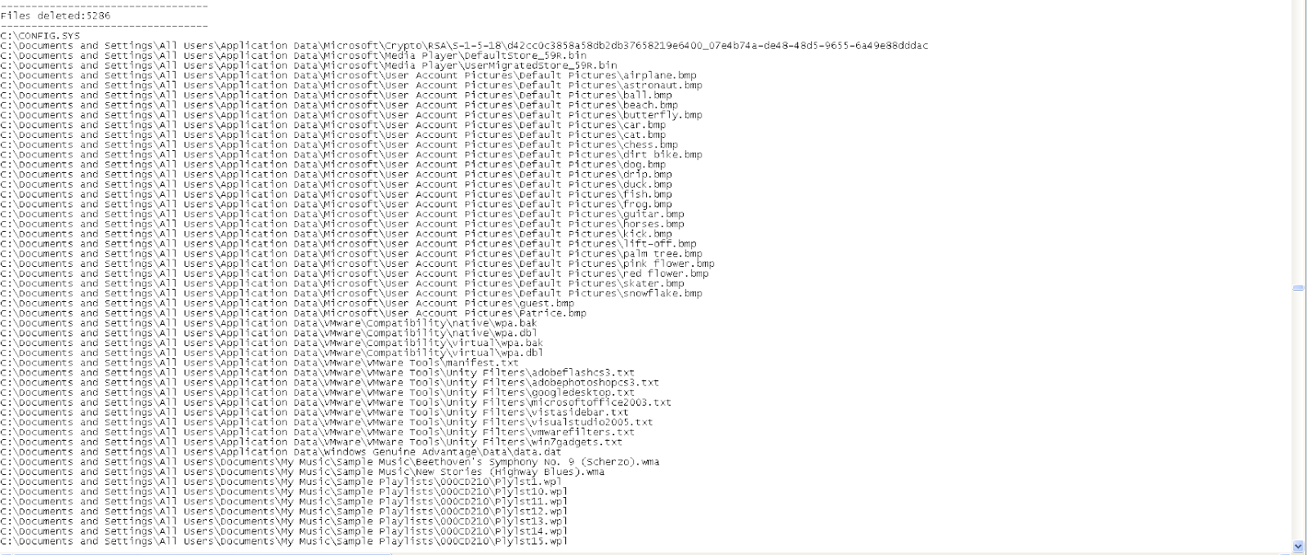

The last thing worth taking note of in regshot is that the malware created a folder called, “Dr watson”. The contents of this folder can be found in Section 3.1.2.1.

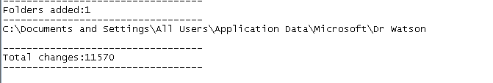

#### 3.1.2.5 Additional Information

This section contains some additional information to take note when conducting the basic dynamic analysis process. Firstly, after the malware execution, we powered off the system and tried to turn on the system again. However, it was found that the system could no longer start. The reason why it was unable to start again is due to “NTLDR” missing. “NTLDR” is used to boot Windows XP operating systems and if it is missing, the operating system can no longer be accessed.

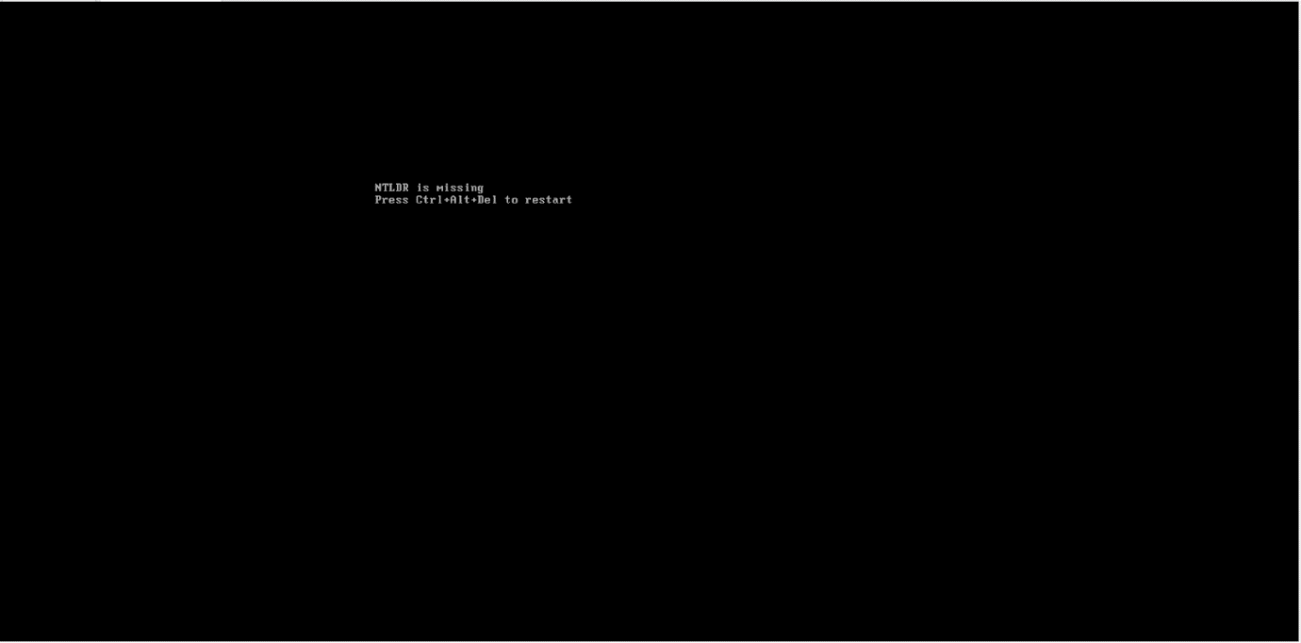

The rest of the tools were not useful in telling us information about the malware. ApateDNS did not manage to identify the system making any suspicious network connections. Likewise, for both netcat listeners listening on both port 80 and port 443, nothing useful was attained. The netcat for port 80 only managed to catch a GET request from au.download.windowsupdate.com which is not relevant to the malware and does not aid in finding what the malware does. There was nothing suspicious being shown on wireshark as well.

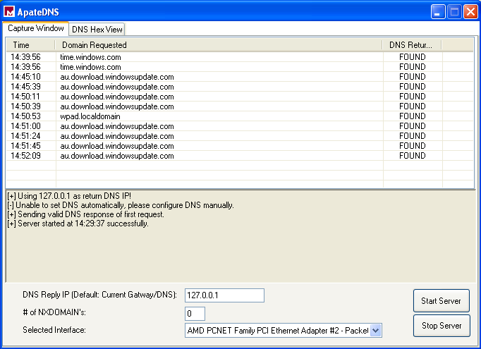

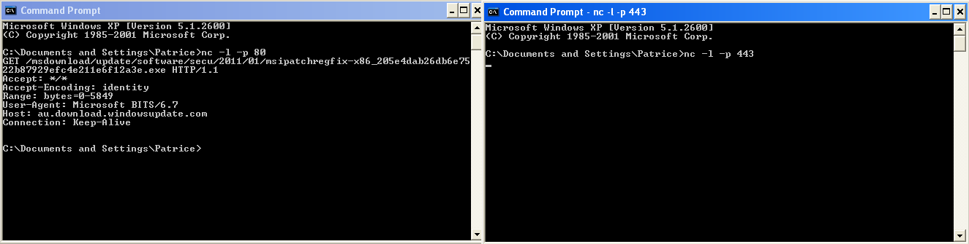

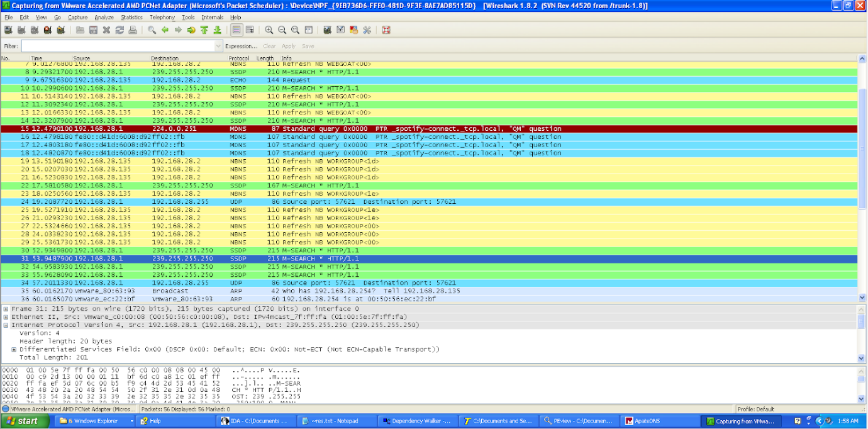

#### 3.1.2.6 Summary of Findings from Basic Dynamic Analysis

In summary, from the basic dynamic analysis we can conclude that the malware is a form of ransomware. When the malware is runned, many changes are observed with the main important changes being the addition of RyukReadMe.html, renaming of files with addition of “.RYK”, and an executable was created by the malware. The files in the system were no longer able to be accessed and the html contains an email address in which the users can contact regarding the inability to access the system files. From there, there is a possibility that the attackers may send them with the price the user needs to pay to unencrypt the files so as to gain access again. The malware appears to be utilising the command prompt so as to launch malicious codes to attack the system. This can be seen from process explorer as many command prompts were launched when the malware was executed. Furthermore, in the process registry, we can see some malicious commands that the malware executed which gives us an idea of what it does to attack the system. It was seen that a file “C:\AUTOEXEC.BAT” was created and accessed which could imply the malware could be using this script to modify system resources. It was also seen that the malware may be using some sort of RSA and AES algorithm for encryption. “Icacls” was seen to be used by the malware to elevate its privileges so as to gain access to every file in the system. The malware also appears to execute “vssadmin.exe” to delete back ups of the system. Lastly, it was found that the malware edits the local boot policy so that windows does not automatically recover errors made and ignore all errors relating to failed boot, failed shutdown, or failed checkpoint. This indicates that the malware may perform actions that may result in boot errors of the system.

### 3.1.3 Results from Advanced Static Analysis

#### 3.1.3.1 Initial Action of Malware

We went to the function call, “StartAddress” to see the initial action of the malware. We can see that the malware calls a Windows function, “GetWindowsDirectoryW”, which retrieves the path of the Windows Directory. This function call returns the value of the length of the string that is copied to the buffer. If it fails, the return value will be zero. Thus, we compared the output to see if the function works. Since the directory, “Documents and settings”, was changed to “Users” from Windows Vista and onwards, it means that this jump is dependent on the Windows version of the operating system. Thus the malware checks to see if the directory “Users” exists in the system. If it does not, it then pushes the directory, “\\Documents and Settings\\Default User\\”. If the directory “Users” exists in the system, it then goes to “\\Users\\Public\\”. Since we are using Windows XP, the code will not jump and push “\\Documents and Settings\\Default User\\”. A file was then created in the corresponding directory. As seen in the basic dynamic analysis, an executable was created by the malware when it was runned, and this file that was created is most likely to represent this executable.

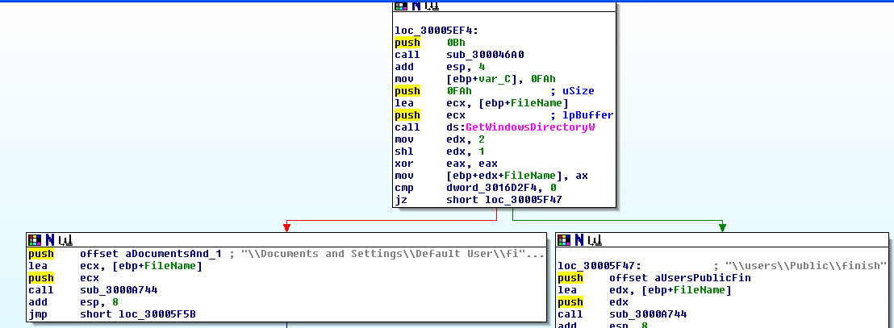

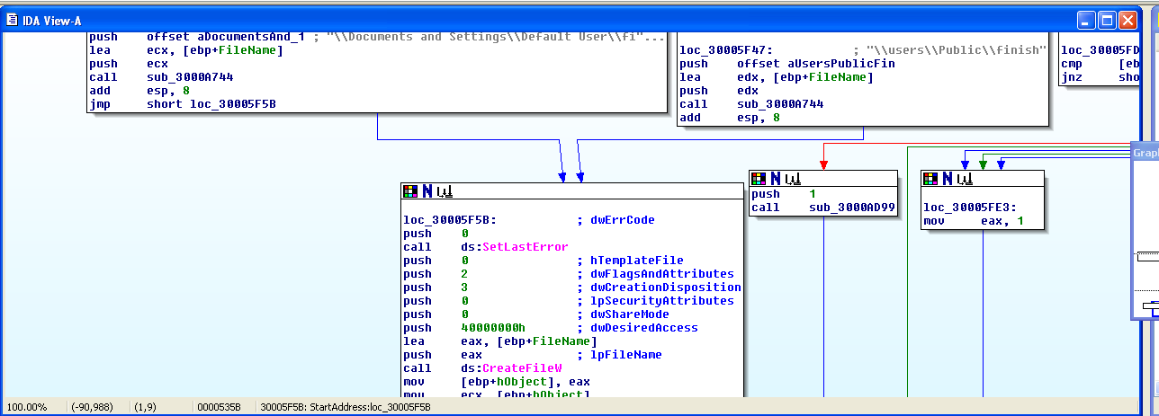

#### 3.1.3.2 Changes Made to Registry

We then went to the “ShellExecuteW()” function call and we can see that the malware once again calls the “GetWindowsDirectoryW” Windows function. This time, the malware is seen trying to access the command prompt, “\\System32\\cmd.exe”.

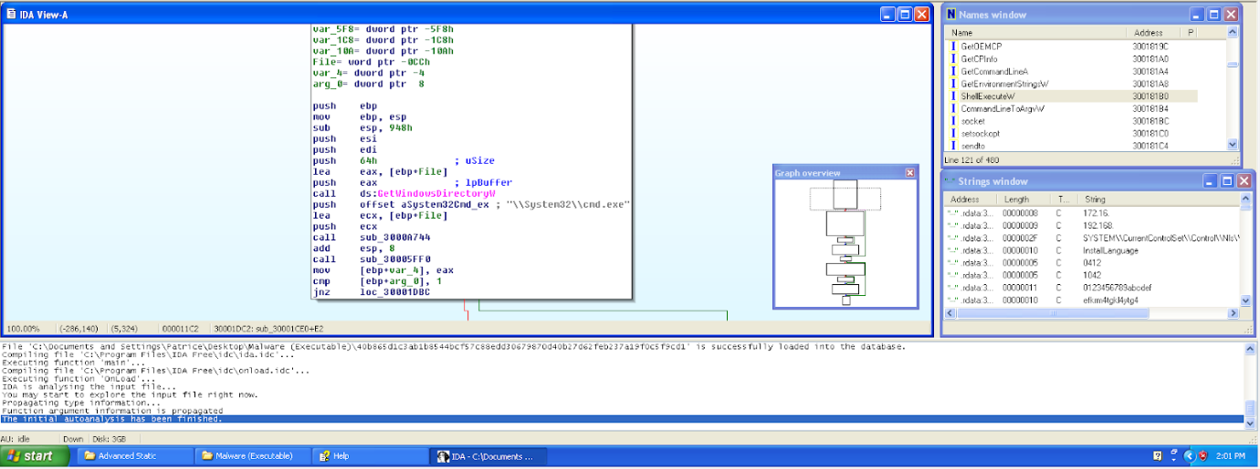

Moving down the ShellExecuteW() Name call, we can see that the malware appears to be creating a new value under the registries with the name, “HKEY_CURRENT_USER\SOFTWARE\Microsoft\Windows\CurrentVersion\Run\svchos”. It appears to be using the command prompt to add in the registry automatically. When “aCRegAddHkey_cu” is hovered on, we can see the command that is being outputted to the command prompt. This command is, “/C REG ADD "HKEY_CURRENT_USER\SOFTWARE\Microsoft\Windows\CurrentVersion\Run" /v "svchos" /t REG_SZ /d ". We can see that this command entered into the command prompt ends with an open inverted command and thus can conclude that the command has not finished yet. We can see that in the command, “push offset aF”, a close inverted comma and “/F” is added. Since the first inputted code ended with “/d”, this led us to believe that the lines of code between the first input and the second input specifies a specific folder in another directory. This specific folder may be created in the registry and can be used by the malware such that it is executed whenever the system is launched.

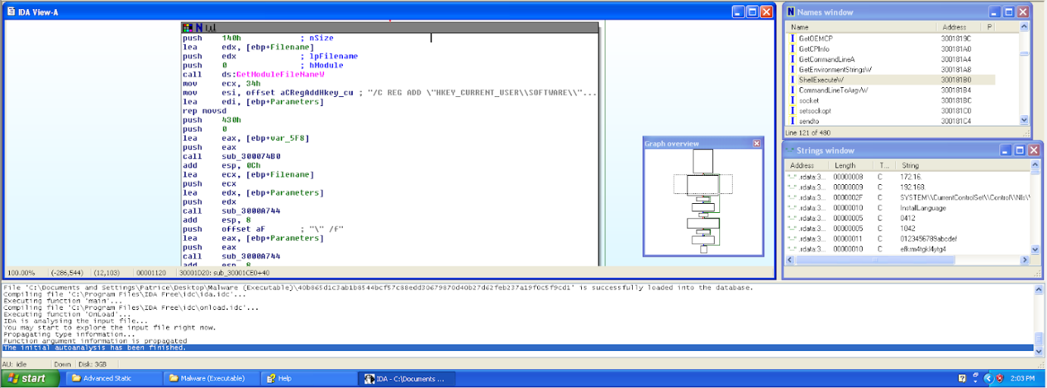

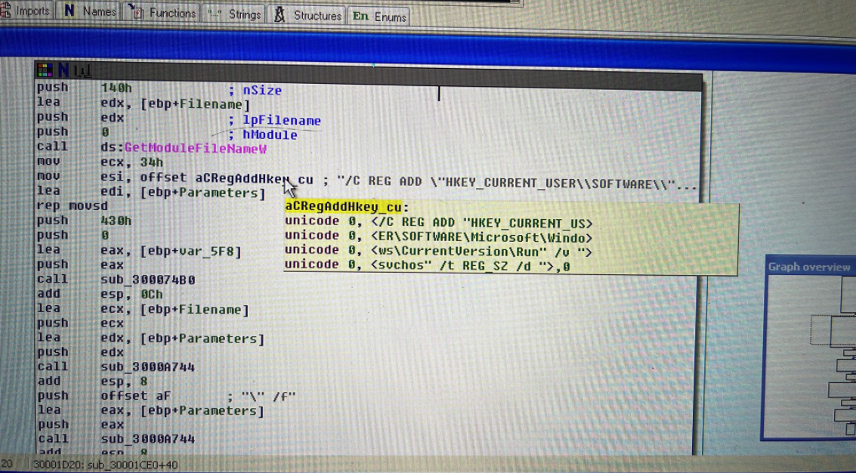

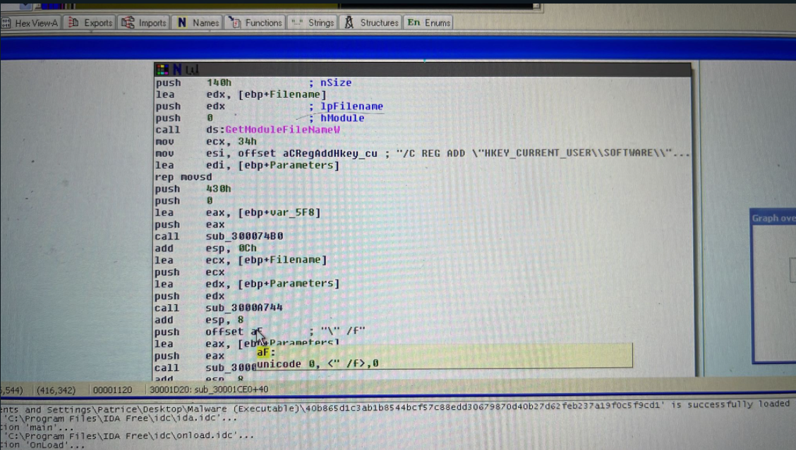

#### 3.1.3.3 Adding of RyukReadMe.html

We were scrolling through the text disassembly view and noticed a comment stating, “RyukReadMe.html”. We can also see many other comments such as “boot”, “PUBLIC” and “PRIVATE”. By referring to section 3.1.2.1, we can see that during basic dynamic analysis, “RyukReadMe.html” was added to every folder in the system. Thus, we suspected the assembly language used here is implying the addition of this html file into every directory of the system.

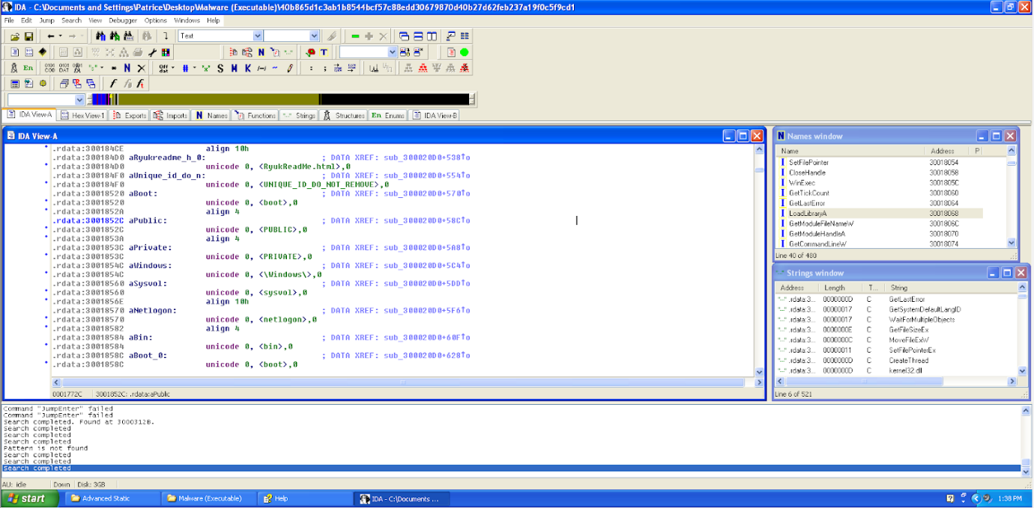

When we viewed the graph of this subroute, we could see that the names of the directories are only pushed when the jump condition is not successfully met. We assume that the code checks if the directory exists and if it does, the result of “test eax,eax” will not be zero, which then leads to the continuation of the next directory. As each directory section, has a code for loading the effective address of “[ebp+vatr_720]”, the memory address of “RyukReadMe.html” could have been saved as “[ebp+var_720]”, which could be linked to the installation of the html file in each directory.

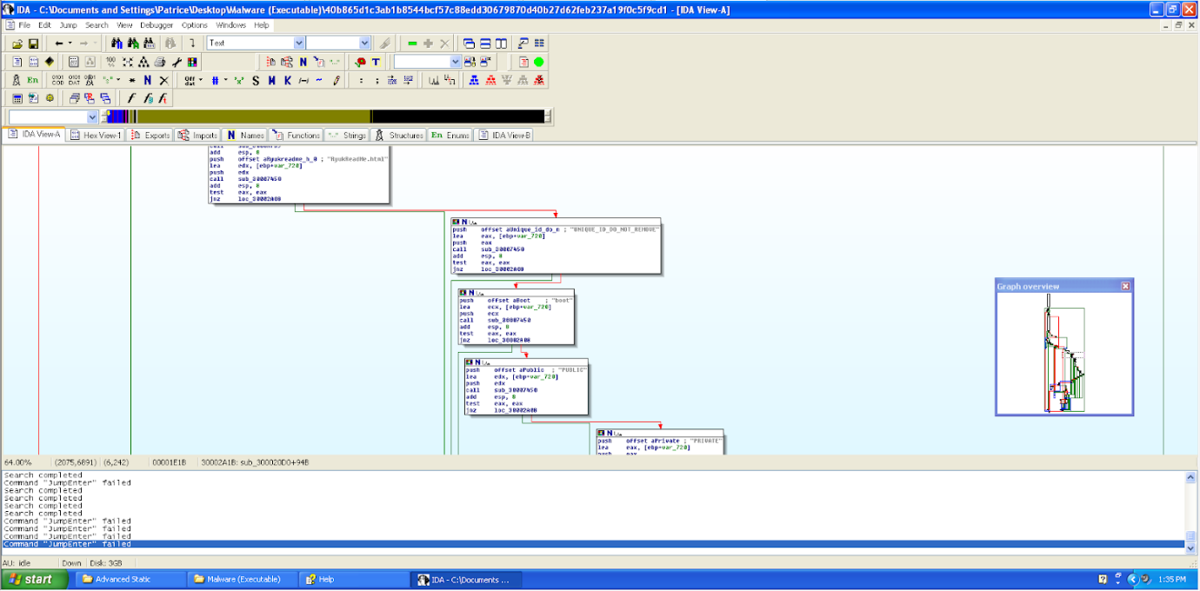

#### 3.1.3.4 Encryption Process

We continued analysing the strings in text disassembly view and identified a suspicious string stating, “encrypt”. Knowing from the results basic dynamic analysis produced, we knew that the files were encrypted and could not be accessed. Thus, we went to the subroutine to take a closer look.

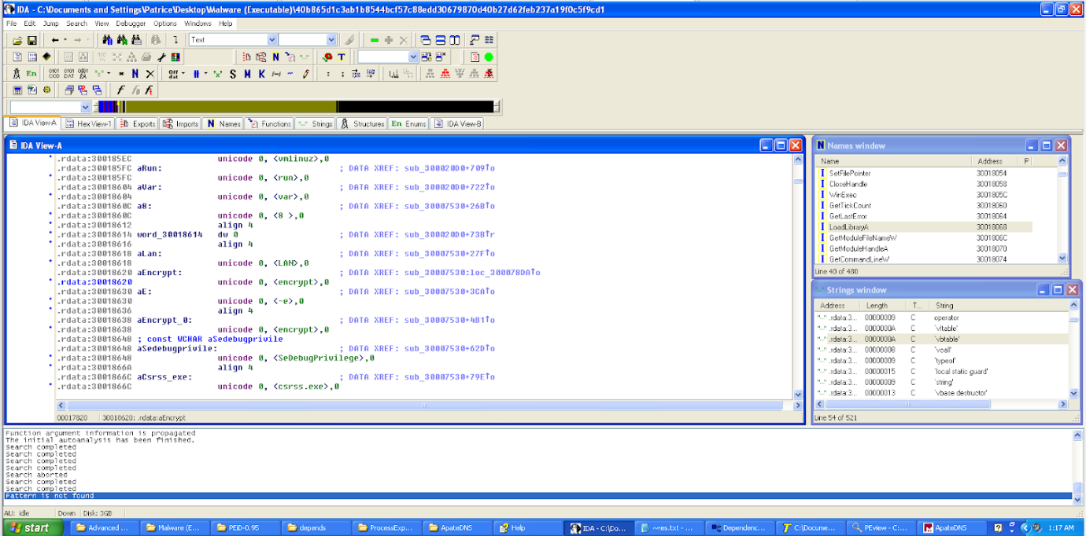

In the subroutine we can see that “aEncrypt 0” is being pushed into a function call. However, we were not able to gain much information on what this function call does other than the fact that the malware was starting an encryption process. Thus, we decided to explore further by going to the next jump location.

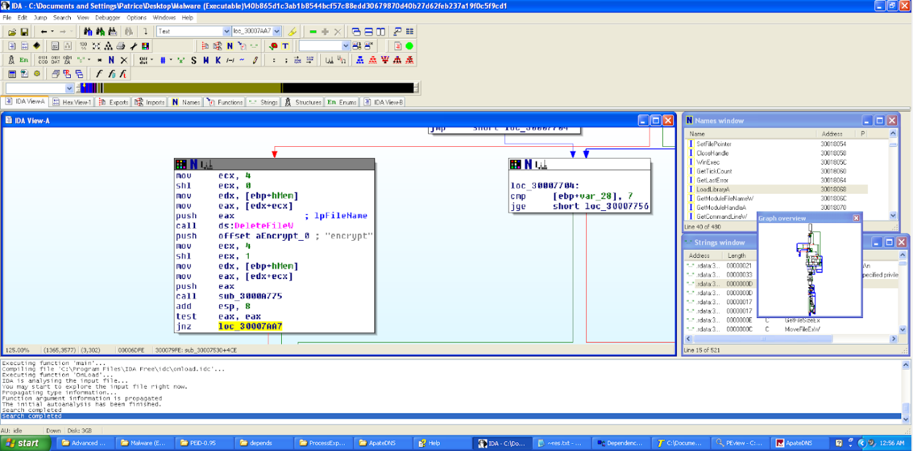

We went to the jump location highlighted, “loc_30007AA7” to see if we can see what the malware is trying to do. In this location, we can see that there are two windows functions being called. They are “LocalFree” and “GetVersionExW”. “LocalFree” frees the specified object local memory and invalidates its handle. This could be malicious as it could mean that the object’s memory will get cleared and the pointer for the object could be deleted which means that the object may not be able to be accessed any longer. “GetVersionExW” identifies the current operating system’s versions which can be used by the malware to see if the encryption process is supported by the operating system and if it is able to be carried out.

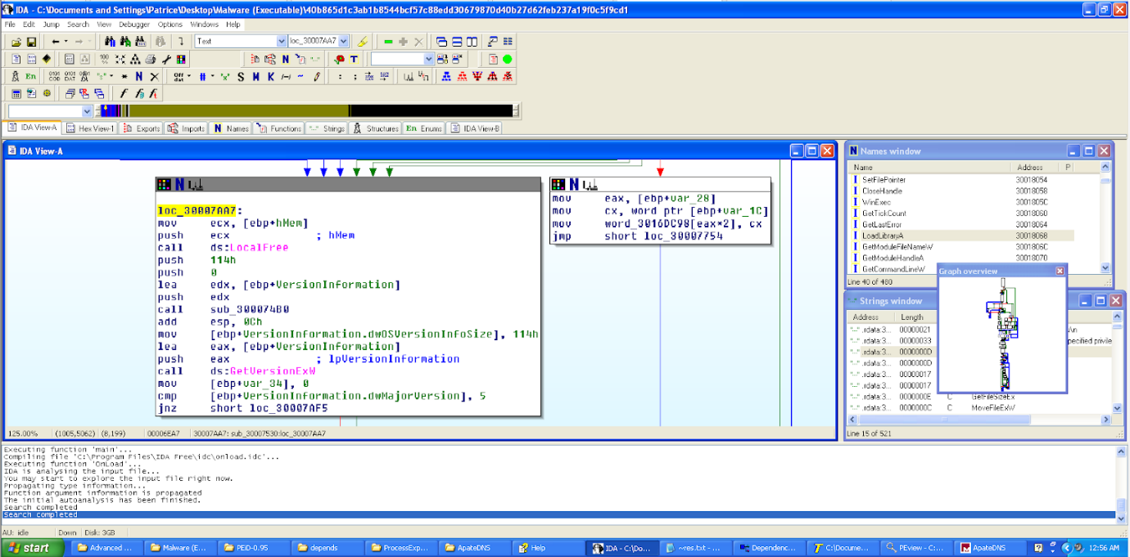

It is suspected that the malware then creates a thread for the encryption of the object. This can be seen as the function “CreateThread” was called. “CreateThread” creates a thread and this thread is executed within the virtual address space of the calling process. Thus, this leaves us to believe that the malware creates a thread to encrypt each object and also removes its handle which results in the objects not being able to be runned, hence “locking” the objects.

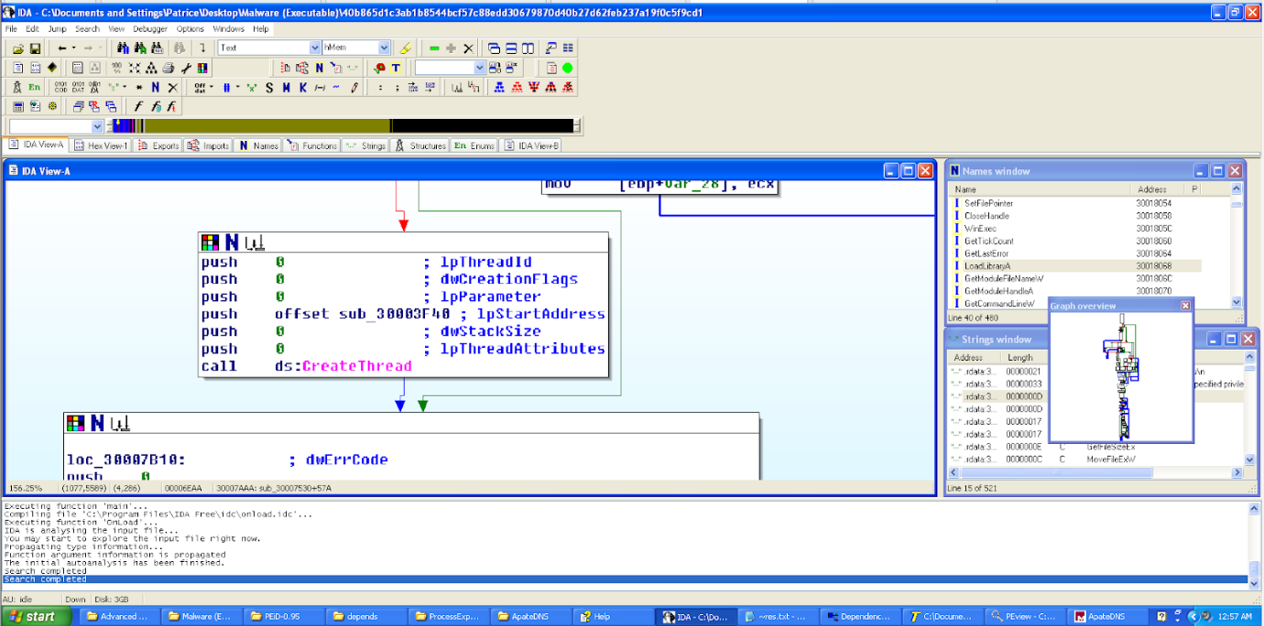

#### 3.1.3.5 Performing Process Injection

We continued exploring the strings and managed to identify a suspicious line. This suspicious line is “SeDebugPrivilege”. We then decided to go to the subroutine to take a closer look.

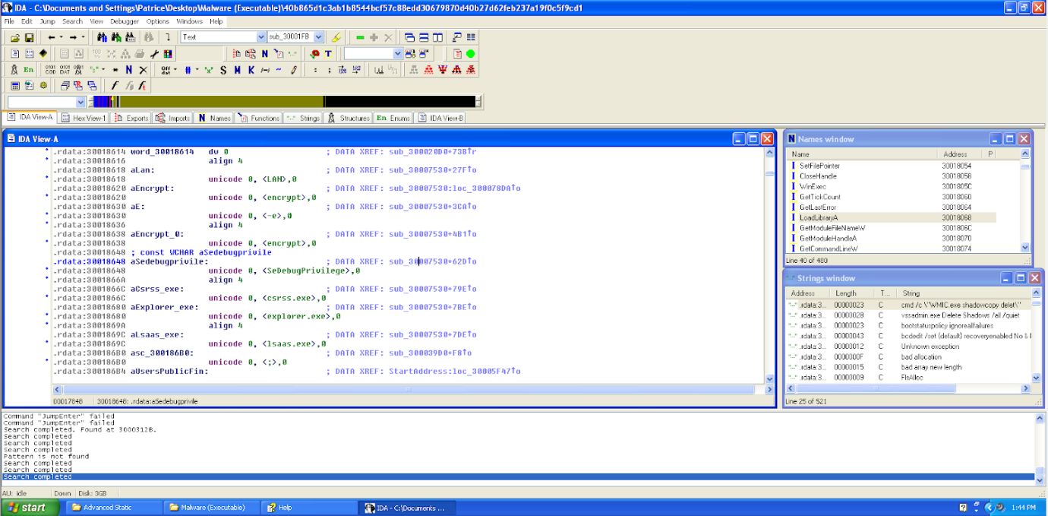

Here we can see that a command, “push offset aSedebugprivile” was done. This command basically grants the malware SeDebugPrivilege which gives the malware the ability to inspect processes and adjust the memory of other processes. This typically is used by the malware to perform process injection.

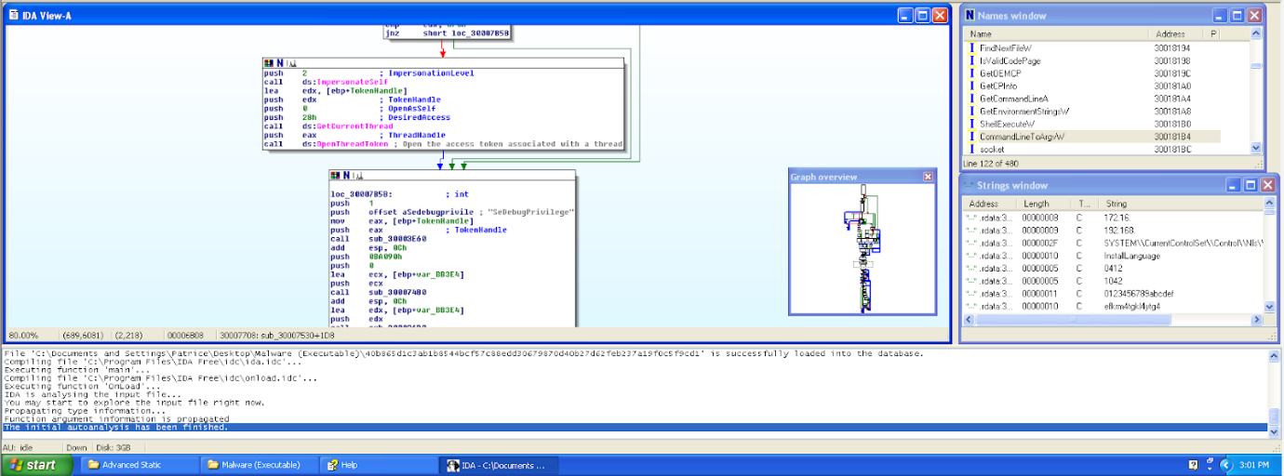

#### 3.1.3.6 Process of Process Injection

In VirtualAllocEx() function call, we can see that the malware allocates memory for its own process at the targeted process memory space. In this allocated memory, it then writes its process using the function WriteProcessMemory(). After writing the process, it then creates a thread using CreateRemoteThread(), which will run the malware thread at the injected process.

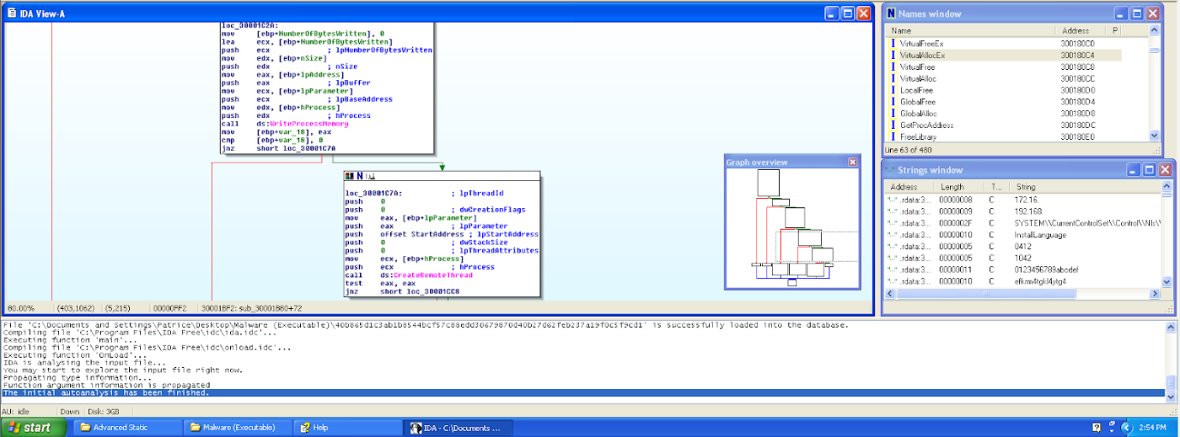

The malware then loops through the processes to perform the process injection. However there are three processes that are excluded from this injection process. The three processes identified are, “csrss.exe”, “explorer.exe”, “lsaas.exe”.

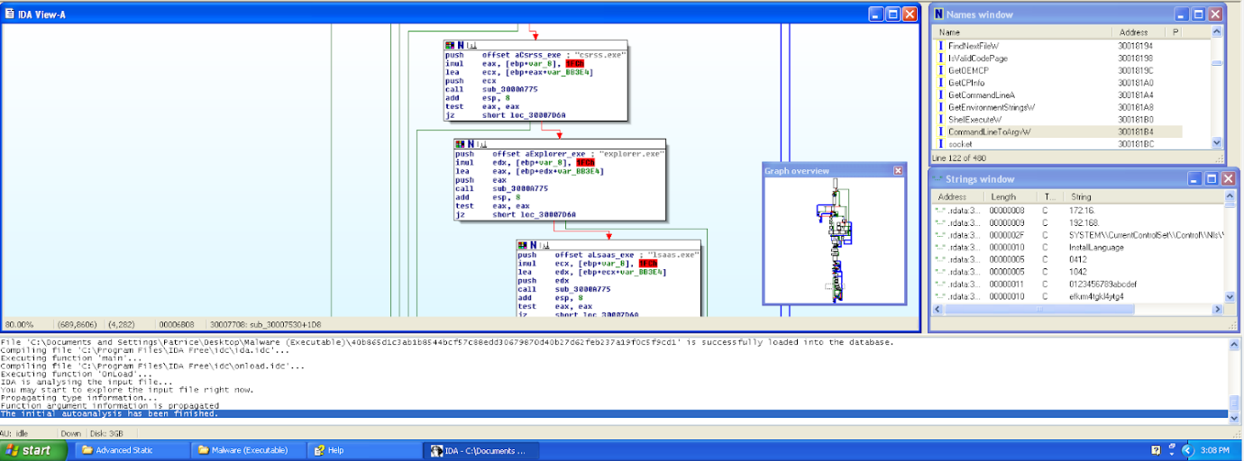

#### 3.1.3.7 Deletion of Shadow Copies

We were searching through the strings where we identified suspicious strings such as “vssadmin.exe Delete Shadows /all /quiet”. We double clicked it and the IDA View A brought us to this screen. We then clicked on the location where this string was identified.

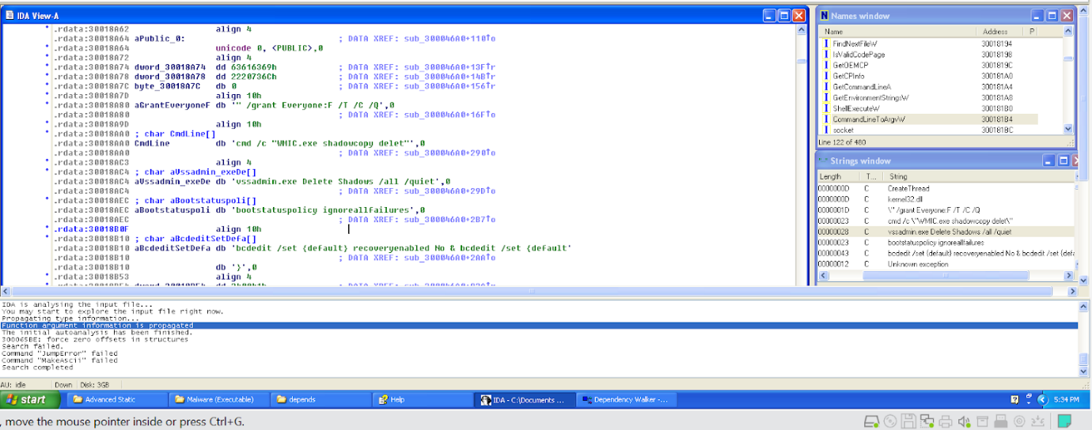

We then went to the subroutine and identified that the malware manages to grant itself SeBackupPrivilege. This gives the malware the ability to retrieve file content. This obviates the need for any ACL-based security check and the malware is able to retrieve all kinds of files. The malware appears to be using the command prompt which can be seen from the command, “push offset aSystem32cmd__0”.

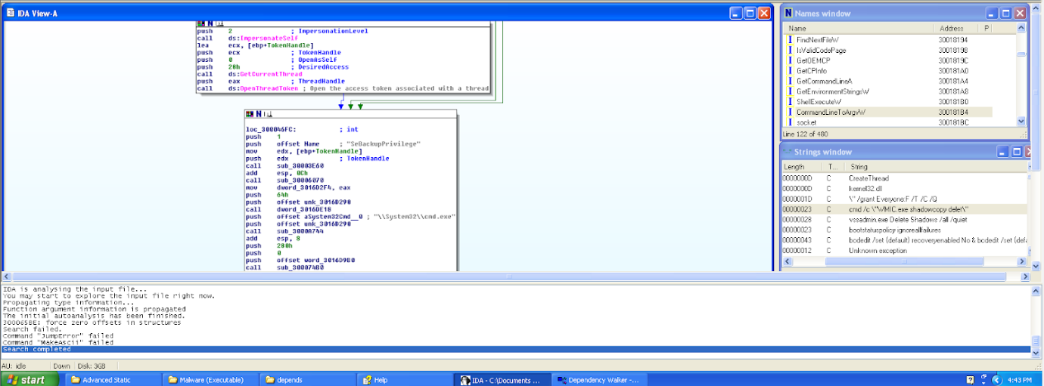

It appears that the malware uses the command prompt to go to either the “\\Documents and Settings\\Default User\\” folder or to the “\\Users\\Public\\” folder. Since the directory, “Documents and settings”, was changed to “Users” from Windows Vista and onwards, it means that this jump is dependent on the Windows version of the operating system. Thus the malware checks to see if the directory “Users” exists in the system. If it does not, it then pushes the directory, “\\Documents and Settings\\Default User\\”. If the directory “Users” exists in the system, it then goes to “\\Users\\Public\\”. Since we are using Windows XP, the code will not jump and push “\\Documents and Settings\\Default User\\”.

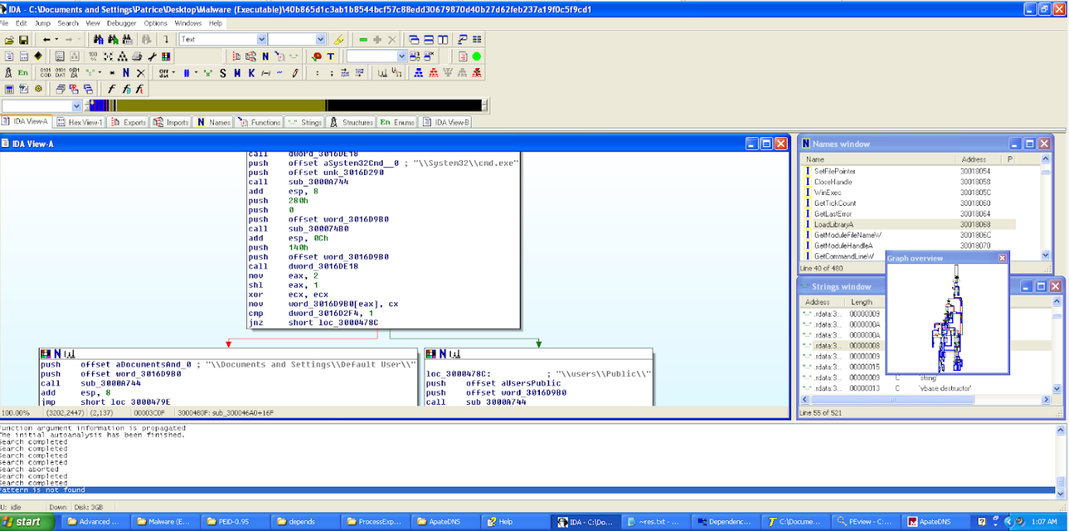

Then, the malware uses the “icacls” command in the command prompt to modify the discretionary access control lists that have been applied on the files in the directory. In the comments, we can see that it stated, “/grant Everyone:F /T /C /Q”. The “/T” parameter means that the operation will be performed on all the specified files in the current directory and its subdirectories. The “/C” parameter means that the operation will continue despite any file errors. Lastly, the “/Q” parameter will suppress success messages.

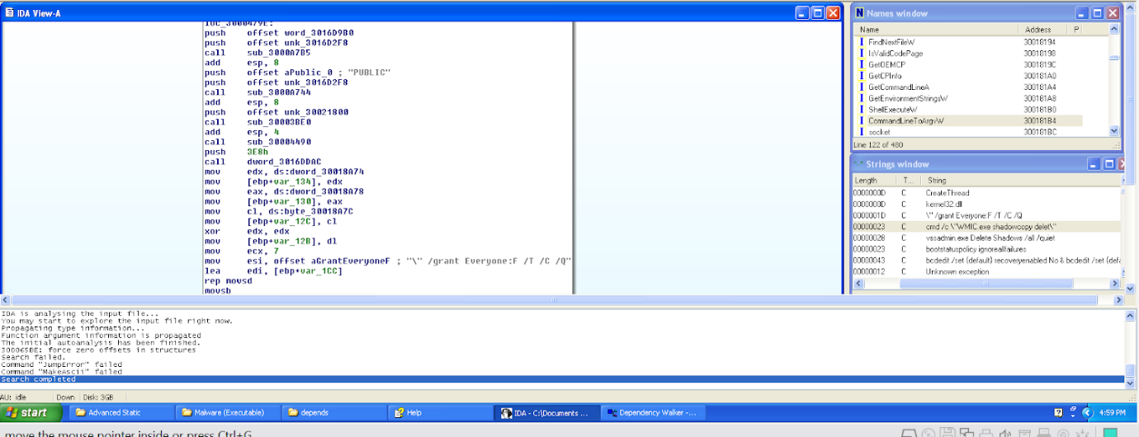

We can then see that the malware then uses the command line to make changes to the files in the directories. As shown in the previous part, the malware modified the discretionary access control lists of the files and thus can access files that even required administrative privileges. We can then see that the malware uses the command line to delete shadows copies in the specified volume. Shadow copies are backup copies or snapshots of computers or volumes that Microsoft Windows uses. The code the malware used is “vssadmin.exe Delete Shadows /all /quiet” which means that all the shadow copies stored in the directory will be deleted and no messages will be displayed while the command is running, which implies that this code will run while in secret to ensure that the user does not know about this.

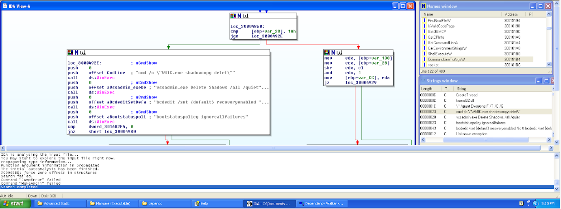

#### 3.1.3.8 Editing of Boot Configuration Data

Next, we can see the malware runs another code, “bcdedit /set {default} recoveryenabled No & bcdedit /set {default}”. If we see the next line, we can also see that “bootstatuspolicy ignoreallfailures” was also entered. In order to use this command, it must be accompanied with “bcdedit /set {default} and thus we can safely assume that the command the malware is trying to execute is, “bcdedit /set {default} recoveryenabled No & bcdedit /set {default} bootstatuspolicy ignoreallfailures”. This command will make it such that Windows will not be able to automatically repair any errors that were detected and that Windows will ignore all errors when there is a failed boot, failed shutdown or failed checkpoint. Thus, we can see from these codes executed from the malware, the malware deletes all shadow copies and possible backups. It also “locks” the operating system by forcing it to ignore all errors and by preventing it from automatically repairing these errors.



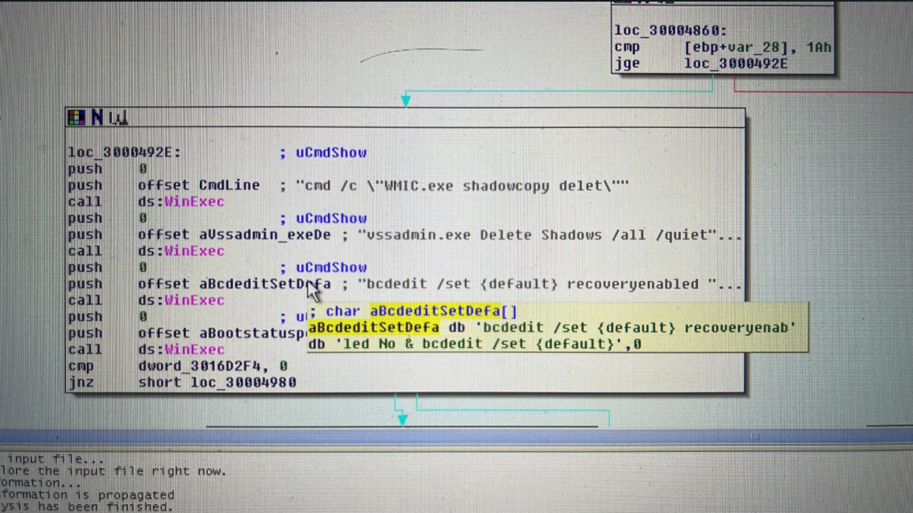

#### 3.1.3.9 Killing Processes

After further analysing the strings, we saw a suspicious string that stated, “taskkill”. As a result, we looked into the subroutine, “sub_30003070” to see if we can find what the malware is trying to achieve.

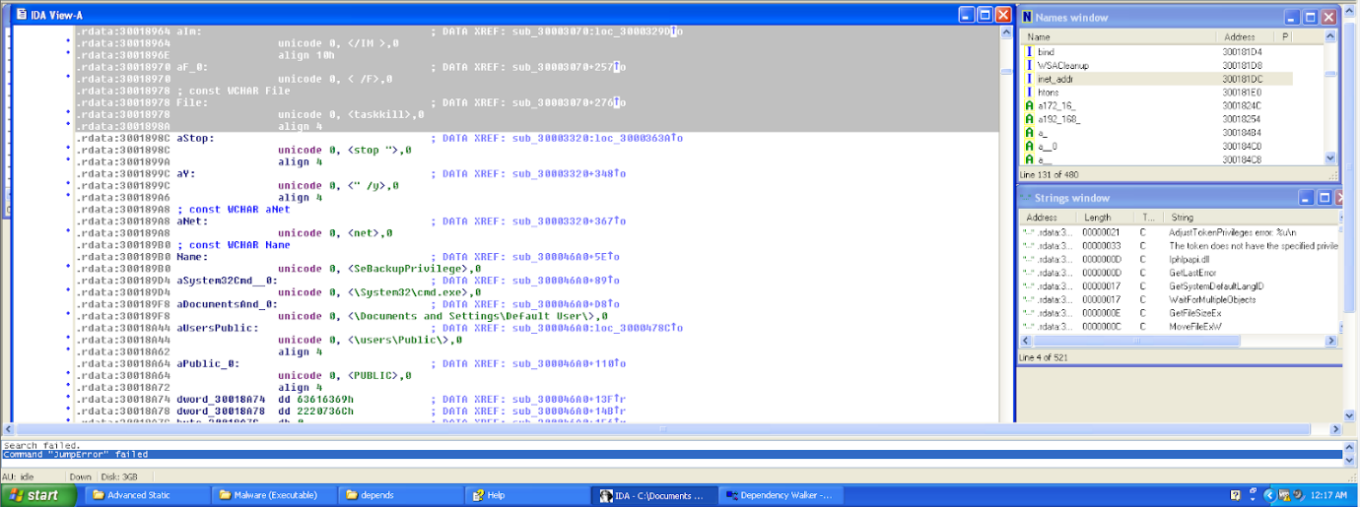

We realised that through the two function calls, “Process32FirstW” and “Process32NextW”, the malware was looping the processes running on the system. It was seen that the malware uses a command called, “taskkill” which kills a process by using the process id or by the image file name. In this case, the malware uses the parameter, “/IM” which means that it is killing processes using the image name. “/F” is used to kill the process forcefully without having the need to have user confirmation. This means that the processes running on the system were then getting killed by the malware, resulting in the inability to perform normal operations.

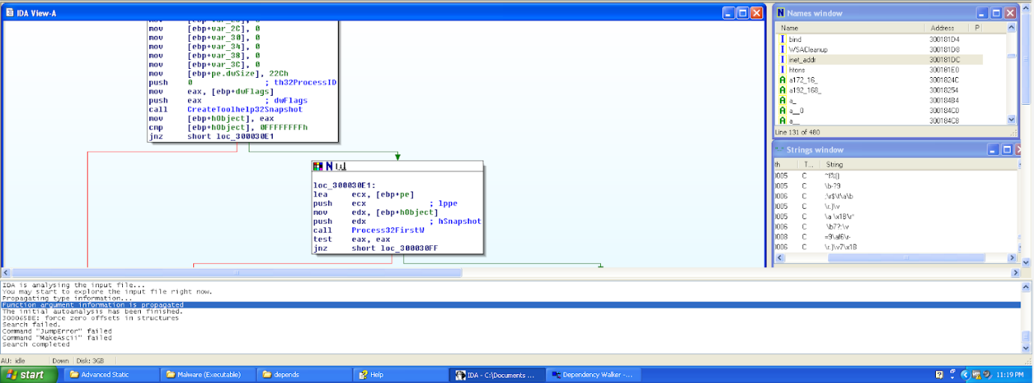

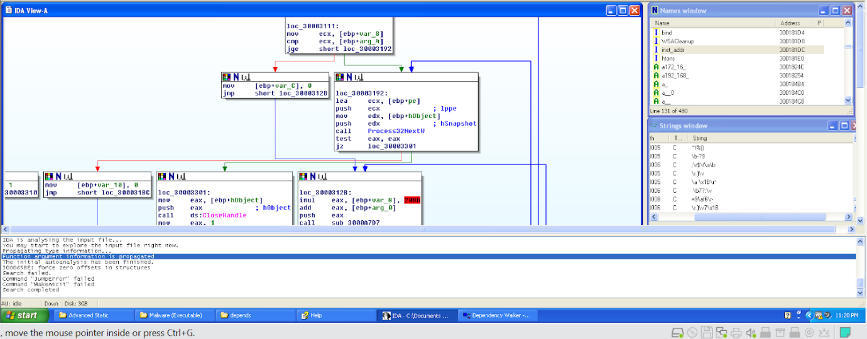

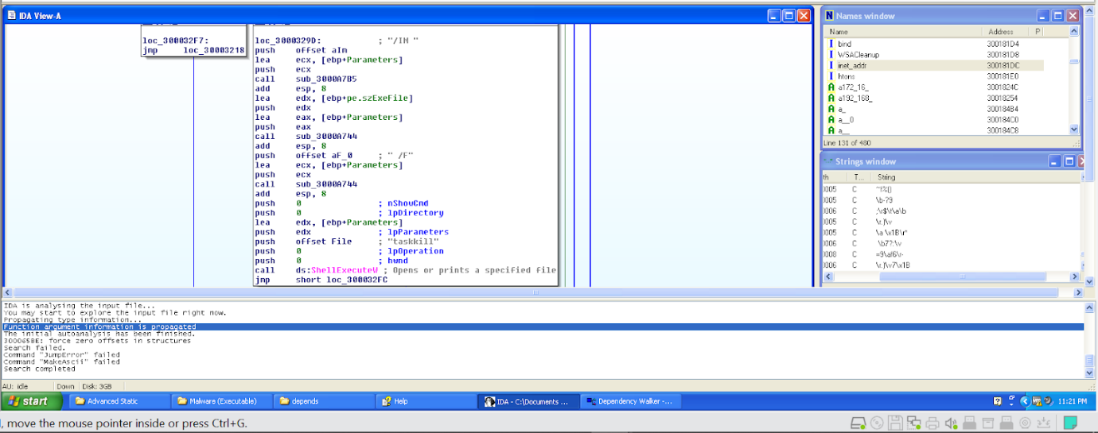

#### 3.1.3.10 Stop Network Services

Further analysis of the strings also points out suspicious comments such as “stop” and “net”. We then decided to take a look at the subroutine to further analyse the malware.

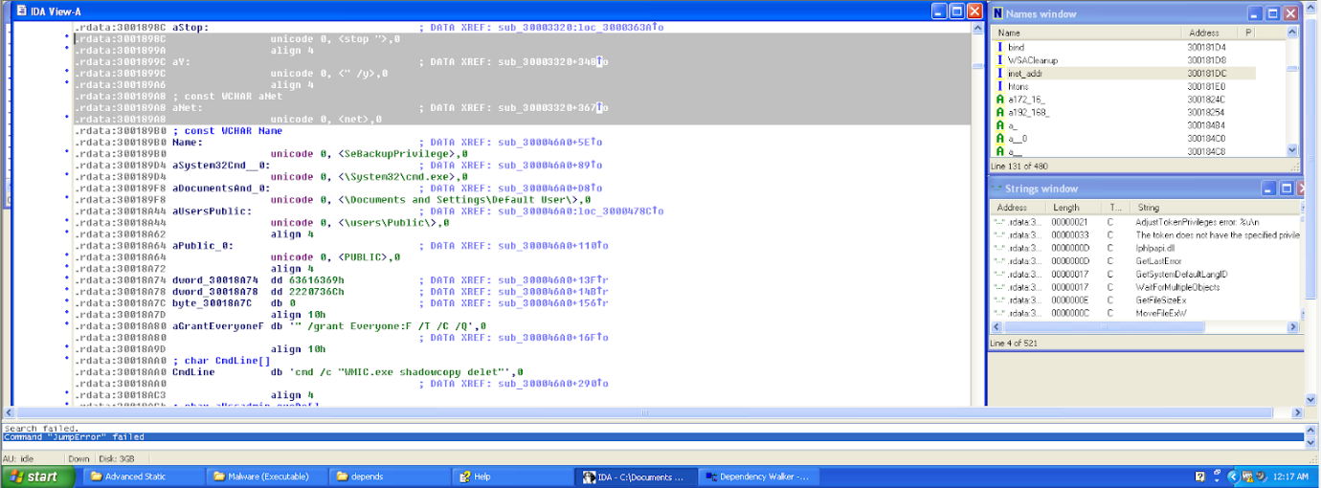

We realised that the malware could be using the command, “net stop “service name” /y”. “net stop “service name”” is used to stop a network service and “/y” is used so that there is no need for user confirmation to stop the service. This means that the malware might be performing this command which prevents the user from using network services. This command is also operated in secret without the user's knowledge.

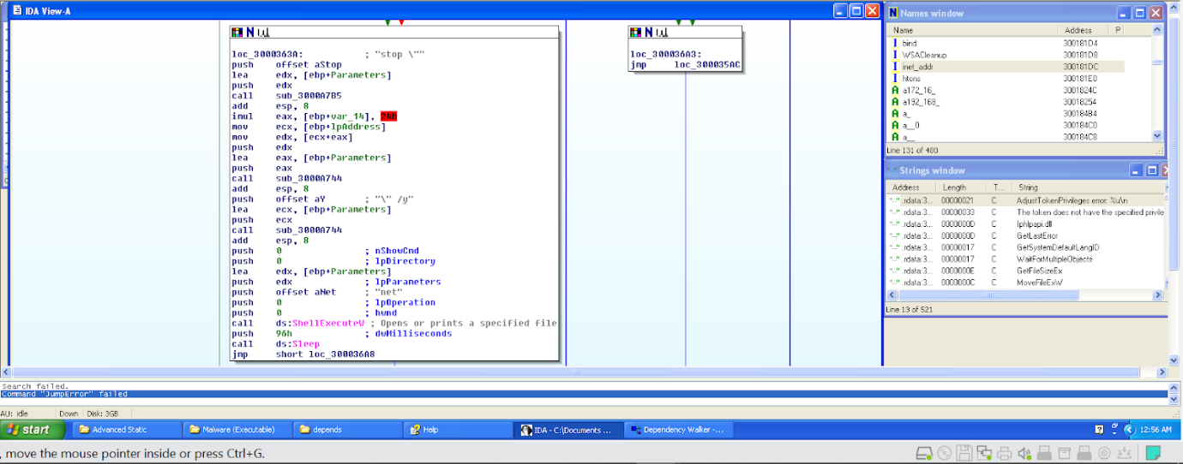

#### 3.1.3.11 Summary of Findings from Advanced Static Analysis

From the findings of advanced static analysis, we can conclude the actions the malware performs when it is executed. We can see that the malware performs many malicious activities. Firstly, the malware uses command prompt and runs a command that installs a folder into the registry, “HKEY_CURRENT_USER\SOFTWARE\Microsoft\Windows\CurrentVersion\Run”. This folder may be used by the malware such that it is executed every time Windows is launched. The malware was also suspected to have performed encryption by using a created thread. This thread encrypts each object and prevents the object from being executed through the removal of its handle. The malware also performs process injection by granting the ability to inspect processes and adjust the memory of other processes. All processes except for “csrss.exe”, “explorer.exe”, “Isaas.exe” gets injected. The malware also grants itself “SeBackupPrivilege” which allows it to retrieve file contents. It also uses “icacls” that modifies the discretionary access control lists that have been applied on the files in the directory. It also deletes shadow copies which are backup copies or snapshots of computers that Microsoft uses. Additionally, it “locks” the operating system by forcing it to ignore all errors related to failed boot, failed shutdown or failed checkpoint, and by preventing it from automatically repairing these errors. It also kills processes as it uses commands such as “taskkill”. Lastly, the malware could be stopping network services running on the system as it might be running the command, “net stop”.